Chapter 2

Questions and Problems and Answers

- Determine whether each of the following arrangements is an option. If so, decide whether it is a call or a put and identify the premium.

  - You purchase home owners insurance for your house.
Homeowners insurance is a put option. In the event of a loss, the insurance company pays you a portion of the value of the house. The rest is like a deductible. The premium on the put is the insurance premium.
  - You are a high school senior evaluating possible college choices. One school promises that if you enroll, it will guarantee your tuition rate for the next four years.
The guaranteed tuition arrangement is a call option granted to you by the school. If you enroll now, you can “purchase” the education at a fixed price up through the next four years. The premium on the option is the fact that you have to enroll in this particular school for your freshman year. Of course you do not have to exercise the option by continuing to enroll thereafter.
  - You enter into a non-cancelable long term apartment lease.
This is not an option because no one has the opportunity to forego exercise. It is actually a forward contract. If the lease were cancelable over the period during which the rental rate was fixed, it would be a call option.

- Explain the difference between an American and a European option. What do they have in common?

An American option can be exercised at any time up through the expiration date. A European option can be exercised only on the expiration date. An American option is equivalent to a European option with the additional feature that it can be exercised early.

- explain each of the terms in the following description of an option:
AT&T Jan 65 Call
The option is on AT&T stock. It expires in January. If it is an exchange-listed option, it expires the Saturday following the third Friday in January. The option is a call with an exercise price of $65 a share. In other words, the option gives the right to buy AT&T stock at $65 a share up to the expiration day in January.

- What adjustments to the contract terms of CBOE options would be made in the following situations?

  - An option has an exercise price of 60. The company declares a 10% stock dividend.
One contract would now cover 110 shares with an exercise price of 60/1.10 or 54.55. This would be rounded to the nearest eighth for 54-1/2.
  - An option has an exercise price of 25. The company declares a two-for-one stock split.
Buyers and writers of outstanding contracts are credited with two contracts for every one previously owned or written. The exercise price is changed to 12-1/2. The contract size is still 100.
  - An option has an exercise price of 85. The company declares a four-for-three stock split.
One contract would now cover 100(4/3) or 133 shares with an exercise price of 85(3/4) or 63.75. Note: In the context of options, a 4-for-3 stock split is the same as a 33 percent stock dividend.
  - An option has an exercise price of 50. The company declares a cash dividend of $ 0.75.
No changes to any contract terms.

- Consider the January, February, March stock options exercise cycles discussed in the chapter. For each of the following dates indicate which expirations in each cycle would be listed for trading in stock options.
  - February 1
  - July 1
  - December 1
 | January Cycle | February Cycle | March Cycle
a | Feb, Mar, Apr, Jul | Feb, Mar, May, Aug | Feb, Mar, Jun, Sep
b | Jul, Aug, Oct, Jan | Jul, Aug, Nov, Feb | Jul, Aug, Sep, Dec
c | Dec, Jan, Apr, Jul | Dec, Jan, Feb, May | Dec, Jan, Mar, Jun

- Why are short puts and long calls grouped together when considering position limits?

Short puts and long calls are both strategies designed to profit in a bullish market. Thus, they are considered to be “on the same side of the market.”

- Compare and contrast the roles of market maker and floor broker. Why do you think an individual cannot be both?

The market maker is an independent operator whose objective is to buy options at one price and sell them for a higher price. A broker is in business to generate commissions on each transaction. A broker does not have to try to guess where the market is going or whether he can earn the bid-ask spread.
CBOE rules allow an individual to be both a market maker and a floor broker but not on the same day. The reason is the potential for a conflict of interest. For example, suppose a situation arises in which the trader has to decide whether to execute a personal transaction or a customer transaction. Whichever transaction is done will bring large profits to the holder of the position. The trader could obviously be tempted to put personal interests ahead of the customer’s interests. The practice of trading as both a market maker and a floor broker is called dual trading.

- Explain how the CBOE’s order book official (OBO) handles public limit orders.

Consider a limit order to buy an option at no more than 3. If there is no offer to sell for 3 or less, the OBO takes the limit order, adds it to the other limit orders, and makes the highest bids known to the traders. If any market maker or broker is willing to lower the ask price to 3 or below, the OBO executes the order. Because the price may not fall to 3, the limit order may never be filled.

- Contrast the market maker system of the CBOE and Pacific Stock Exchange with the specialist system of the Amex and Philadelphia Stock Exchange. What advantages and disadvantages do you see in each system?

In the market maker system, an individual trader who is not a broker is required to be a market maker. That is, the trader must be willing to quote a bid and an ask price on certain options. In the specialist system, there is an individual called the specialist who is charged with making a market in certain options. In addition, there are registered option traders who trade on their own but are not required to make a market. The market maker system puts the role of the specialist and registered option trader in one person, the market maker. Exchanges using the specialist system claim that it has the advantage of specialized expertise in keeping the market fair and orderly. Proponents of the market maker system argue that because the specialist is a monopolist, the cost to the public is much higher than under the market maker system, which encourages market makers to compete with each other for the public’s business.

- Suppose you are an individual investor with an options account at a brokerage firm. You purchase 20 call contracts at a price of $ 2.25 each. Explain how your premium ends up at the clearing house.

Since each contract covers 100 shares, your 20 calls cover 2,000 shares. Thus your premium is $4,500. You pay your premium to your broker. Your broker’s firm must clear its options trades through a clearing firm, which is a member of the Options Clearing Corporation (OCC). Your broker’s firm sends the money to the clearing firm, which deposits it with the OCC. The clearing firm does not actually have to deposit your money with the OCC. It is allowed to consolidate its accounts and using a predetermined formula, it deposits the required amount with the clearing house.

- Compare and contrast the exercise procedure for stock options with that for index options. What major advantage does exercising an index option have over exercising a stock option?

If a call stock option is exercised, the writer delivers the stock to the buyer and receives the exercise price. If a put is exercised, the buyer delivers the stock to the writer and receives the exercise price. If a call index option is exercised, the writer pays the buyer the difference between the stock price and the exercise price. For a put, the writer pays the buyer the difference between the exercise price and the stock price. The major advantage of exercising the index option rather than a stock option is not having to handle the stock. This results in significantly lower transaction costs

- Discuss the limitations of prices obtained from newspapers such as The Wall Street Journal.

Besides the fact that stock and option prices are already dated by the time they appear in newspapers, these prices are not synchronized. The prices shown are only the prices of the last trade. The last trade of the stock may not have taken place at the same time as the last trade of the option. In addition, the stock and options markets do not even close at the same time. Moreover, the prices appearing in the newspapers do not indicate whether the last trade was at a bid price or an ask price.

- Discuss the three possible ways in which an open option position can be terminated. Is your answer different if the option is created in the over-the-counter-market?

An option position can be terminated by simply executing an offsetting order in the market. For example, suppose in January you bought a Microsoft March 90 call for 5 3/8. In the middle of February it is selling for 6 ¼ and you would like to take your profit. You simple sell a Microsoft March 90 call, which offsets your long position. An option can also be closed by exercising it. You would notify your broker that you want to buy the stock at the exercise price (if a call) or sell at the exercise price (if a put). The third way an option position can be terminated is by expiring out-the-money. If it is not advantageous to exercise it by the expiration, the option simply expires and your position is terminated. In the over the-counter market, you can certainly exercise the option or have it expire out-of-the-money. While you can effectively offset a position by opening up a new but opposite contract, the procedure is technically somewhat different than in the exchange-listed options market. In the latter market, the contracts cancel each other and no further obligation is incurred. In the over-the-counter-market, both contracts remain in force and consequently each is subject to default on the part of the writer.

- Name and briefly describe at least two other instruments that are very similar to options.

Among the option-like instruments are warrants, convertibles and callable bonds. A warrant is an option offered by the firm on its own stock. A convertible is a bond or preferred stock that can be converted into common stock at a fixed rate at the holder’s discretion. Callable bonds are bonds that can be retired early at a specific price at the discretion of the issuing firm. In addition firms issue options similar to warrants to executives and employees. Finally, we should note that stock itself is like a call option held by the stockholders and written by the bondholders.

- Identify and briefly discuss the various types of options transactions cost. How do these costs differ for market makers, floor brokers, and firms trading in the over-the-counter-market?

Floor trading and clearing fees run from $0.50 to $1.00. These represent the costs of paperwork involved in processing the trade as well as the exchange’s overhead. Commissions, which reflect the cost of the labor involved in arranging the trade, vary and depend on the type of broker (discount or full service). The bid-ask spread is the cost of providing liquidity to the market. The public and floor brokers representing the public incur all of these costs while market markers incur floor trading and clearing fees and may incur the bid-ask spread if they have to deal with other market makers instead of the public.
Transactions in the OTC market do not generally incur commissions and floor trading and clearing fees. They do incur costs of paperwork and, in particular, the legal expenses of laying out the rights of each party. Since transactions in the OTC market are generally executed through dealers, they incur the dealer’s bid-ask spread.

- Using the commission schedule in table 2.3, determine the commissions on the following option transactions:

  - One contract at a price of 2 7/8
$287.50(0.016) + $29 = $33.60
Minimum charge = $37.25 + $ 1.75 = $39
Maximum charge = $40
So commission is $39
  - Five contracts at a price of 8 ½
$4,250(0.008) + $49 = $83
Minimum charge = $37.25 + 5($1.75) = $46
Maximum charge = 2($40) + 3($4) = $92
So commission is $83
  - Twenty contracts at a price of 4 ¾
$9,500(0.008) + $49 = $125
Minimum charge = $37.25 + 20($1.75) = $72.50
Maximum charge = 2($40) + 18($4) = $152
So commission is $125

- Explain the major difference between the regulation of Exchange-Traded Options and over-the-counter-options.

Exchange-traded options are regulated by the Securities and Exchange Commission. There is essentially no regulation of OTC options transactions. However, firms that trade in OTC market are typically regulated by the National Association of Securities Dealers or, if they are banks, by banking regulators.

Appendix 2 A

Questions and Problems and Answers

- Suppose a stock is currently priced at $50. The margin requirement is 20 percent on uncovered calls and 50 percent on stocks. Calculate the required margin, in dollars, for each of the following trades:
  - Write 10 call contracts with an exercise price of 45 and a premium of 7.
  - Write 10 call contracts with an exercise price of 55 and a premium of 3.
  - Write 10 put contracts with an exercise price of 45 and a premium of 3.
  - Write 10 put contracts with an exercise price of 55 and a premium of 7.
  - Buy 1,000 shares of stock and write 10 call contracts with an exercise price of 45 and a premium of 7
  - Buy 20 put contracts with an exercise price of 50 and a premium of 5.

Answers:

- 10[0.2($5,000)+$700] = $17,000
- 10[0.2($5,000)-($5,500-$5,000)+$300] = $8,000
- 10[0.2($5,000)-($5,500-$4,500)+$300] = $8,000
- 10[0.2($5,000)+$700] = $17,000
- The stock price exceeds the exercise price so only 1,000($45)(0.5) or $22,500 can be borrowed. However, the call premium can be applied so the investor must come up with only $22,500-$7,000 = $15,500.
- 20($500) = $10,000. One Hundred percent margin must be posted on all option purchase transactions.

Appendix 2 B

Questions and Problems and Answers

- Suppose a stock is priced at $30 and an eight-month call on the stock with an exercise price of $25 is priced at $6. Compute the taxable gain and tax due for each of the following cases assuming your tax bracket is 28 percent. Assume 100 shares and 100 calls.

  - Your buy the call. Four months later, the stock is at $28 and the call is at $4.50. You then sell the call.
$450 - $600 = -$150. The $150 loss applies against other taxable
income and reduces taxes by $150 (0.28) = $42.

  - You buy the call. Three months later, the stock is at $31 and the call is at $6.50. You then sell the call.
$650 - $600 = $50. The tax is $50 (0.28) = $14

  - You buy the call. At expiration, the stock is at $32. You exercise the call and sell the stock a month later for $35.
The stock is treated as having being purchased for $25 + $6 = $31. The taxable gain is $3500 - $3100 = $400. The tax is $400(0.28) = 112.

  - You buy the stock and write the call. You hold the position until expiration, whereupon the stock is at $28.
The call would be exercised. You deliver the stock and receive $25 for it. The sale price of the stock for tax purposes is $25 + $6 = $31. You purchase the stock at $30. The tax is ($3100 - $3000) (0.28) = $28.

  - You write the call. Two months later, the stock is at $28 and the call is at $3.50. You buy back the call.
The taxable gain is $600 - $350 = $250. The tax is $250(0.28) = $70

- Consider an index option. The index is at 425.48, and a two-month call with an exercise price of 425 is priced at $15. You are in the 31 percent tax bracket. Compute the after-tax profit for the following cases. Assume 100 calls.

  - You buy the call. One month later, the index is at 428 and the call is at $12. You sell the call.
Your loss is 100($15-$12)=$300. This is netted against other gains for a tax savings of $300(0.31)=$93. The after tax profit is
-$300+$93= -$207
  - You buy the call and hold it until expiration, whereupon the index is at 441.35. You exercise the call.
You exercise the call and receive $100($441.35 - $425) = $1635. Your profit is $1635 - $1500 = $135. The tax is $135(0.244) = $32.94. The after tax profit is $135 - $32.94 = $102.06
  - You hold the call until expiration, when the index is at 417.15.
The call expires worthless. You loss is $1500. This is netted against other gains for tax savings of $1500(0.31) =$465. The after tax profit is -$1500 +$465 = -$1035.
  - How will your answers in parts a and b be affected if the option positions are not closed out by the end of the year?
Taxes are paid at the end of the year on all trading profits whether the positions are closed out or not. Thus, in a. and b. , if the end of the year came before you sold or exercise the call, you would owe taxes on any profits or be able to deduct any losses accumulated upto that time.

- Which of the following would be a wash sale? Explain.

  - You buy a stock at $30. Three weeks later you sell the stock at $26. Two weeks later you buy a call on the stock.
This would be a wash sale. You replace the stock with a call option within the 61-Day period. The loss on the stock is not deductible for the tax purposes.
  - You buy a stock at $40. One month later, you buy a call on the stock. One week later, you sell the stock for $38.
This would be a wash sale because you acquire the call within a 61-day period surrounding the sale of the stock. It does not matter that you acquired the call before you sold the stock.
  - You buy a stock for $40. Three months later, you sell the stock for $42 and buy a call on the stock.
This is not a wash sale. The wash sale rule pertains only to cases where the stock is sold at a loss. The rule prohibits deducting the loss. In this case, the stock was sold at a gain so the wash sale rule has no effect.
Chapter 3

Questions and Problems and Answers

- Consider an option that expires in 68 days. The bid and ask discounts on the treasury bills maturing in 67 days are 8.20 and 8.24, respectively. Find the approximate risk free rate.

The average of the bid and ask discounts is 8.22.
Discount = 8.22(68/360) = 1.5527
Price = 100 – 1.5527 = 98.4473
Yield = (100 / 98.4473)^{(365/68)} – 1 = 0.0876
Note that even though the T-Bill matured in 67 days, we must use 68 days since that is the options time to expiration.

- What would happen in the options market if the price of an American call were less than the value Max[0, S-E] ? Would your answer differ if the option were European?

This would create an arbitrage opportunity. The call would be purchased and immediately exercised. For example, suppose S=44, E=40, and the call price is $3. Then an investor would buy the call and immediately exercise it. This would cost $3 for the call and $40 for the stock. Then the stock would be immediately sold for $44, netting a risk free profit of $1. In other words, the investor could obtain a $44 stock for $43. Since everyone would do this, it would drive the price of the call up to at least $4. If the call were European however, immediate exercise would not be possible (unless, of course, it was the expiration day), so the European call could technically sell for less than the intrinsic value of the American call. We saw, though, that the European call has a lower bound of the stock price minus the present value of the exercise price (assuming no dividend). Since this is greater than the intrinsic value, the European call would sell for more than the intrinsic value. Then at expiration, it would sell for the intrinsic value.

- In this chapter, we did not learn how to obtain the exact price of a call without knowing the price of the put and using put-call parity. In one special case, however, we can obtain an exact price for a call. Assume the option has an infinite maturity then use the maximum and minimum values we learned in this chapter to obtain the prices of European and American call.
European call: We know that its price cannot exceed S but must exceed Max[0, S-E(1+R)^{-T}]. With an infinite time to expiration, the present value of E is 0 so the lower bound is S and, since upper bound is S the call price must be S.
American Call: We know that its price cannot exceed S but it must be at least as valuable as a European call. Thus its value must also be S. Note that if exercise early it would be worth only S – E so it will never be exercised early.
- Why might two calls or puts alike in all respects but time to expiration have approximately the same price?
Ordinarily the option with the longer time to expiration would sell for more. If both options were deep out-of-the-money, however, they could both sell for essentially nothing. The market would be expecting that both the shorter and longer lived options will expire out-of-the-money.
- Why might two calls or puts alike in all respects but exercise price have approximately the same price?
If both options were deep out-of-the-money, they might have prices of zero. As in the previous question the two options are expected to expire out-of-the-money.
- Suppose you observe a European call option that is priced at less than the value Max[0, S-E (1+r)^{-T} ] . What type of transaction should you execute to achieve the maximum benefit?
The call is underpriced, so buy the call, sell short the stock, and buy risk-free bond with face value of E. The cash received from the stock is greater than the cost of the call and bond. Thus, there is a positive cash flow upfront. The payoffs from the portfolio at expiration are as follows:
If S_{T} < E,
- S_{T} (from the stock)
E (from the bonds)
The total, E - S_{T}, is positive

If S_{T} >= E,
S_{T} -E (from the call)
S_{T} (from the stock)
E (from the bonds)
The total is zero
The portfolio generates a positive cash flow upfront and there is no cash outflow at expiration.

- Explain why an option’s time value is greatest when the stock price is near the exercise price and why it nearly disappears when the option is deep in our out of the money.
Time value is a measure of the amount of uncertainty in an option. Uncertainty relates to whether the option will expire in-or out-of-the-money. When the option is deep in-the-money, there is little uncertainty about the fact that the option will expire in-the-money. The option will then begin to behave about like the stock. When the option is deep-out-of the money, there is little uncertainty since it is likely to finish out-of-the-money. When the option is at-the-money there is considerable uncertainty about how it will finish.

- Critique the following statement, made by an options investor; “My call option is very deep in the money. I don’t see how it can go any higher. I think I should exercise it”.
Assuming the stock pays no dividends, there is no reason to exercise a call early (this obviously presumes the call is American). The tendency to believe that exercising an option because the stock can go up no further ignores the fact that an option can generally be sold. Exercising an option throws away any chance that the stock can go up further. If the stock falls, the option holder would be hurt, but if the option holder exercised and became a stock holder, he would also be hurt by a falling stock price. There is simply no reason to give away the time value that arises because of the possibility that the stock can always go further upward. In simple, mathematical terms, exercising captures only the intrinsic value S-E. The call can always be sold for at least S- E(1+R)^{-T}.
- Call prices are directly related to the stock’s volatility. Yet higher volatility means that the stock price can go lower. How would you resolve this apparent paradox?
The paradox is resolved by recalling that if the option expires out-of-the-money, it does not matter how far out-of-the-money it is. The loss to the option holders is limited to the premium paid. For example, suppose the stock price is $24, the exercise price is $20, and the call price is $6. Higher volatility increases the chance of greater gains to the holder of the call. It also increases the chance of a larger stock price decrease. If, however, the stock price does end up below $20, the investor’s loss is the same regardless of whether the stock price at expiration is $19 or $1. If the stock were purchased instead of the call, the loss would obviously be greater if the stock price went to $1 than if it went to $19. For this reason, holders of stocks dislike volatility, while holders of calls like volatility. A similar argument applies to puts.
- The value Max[0, E (1+r)^{-T} - S] was shown to be the lowest possible value of a European put. Why is this value irrelevant for an American put?
The minimum value of an American put is Max(0,E-S). This is always higher than the lower bound of a European put, E (1+r)^{-T} – S, except at expiration when the two are equal.
- Why do higher interest rates lead to higher call option prices but lower put option prices?
When buying a call option, one hopes to exercise it at a later date. Thus, the exercise price will be paid out later. If interest rates are higher, additional interest can be earned on the money that will eventually be paid out as the exercise price. When buying a put option, one hopes to exercise it later, thus receiving the exercise price. If interest rates are higher, the put is less valuable because the holder is forgoing interest by having to wait to exercise the put. Higher interest rates make the present value of the exercise price be lower in the case of the call this is good because the call holder anticipates having to pay out the exercise price. For the put holder this is bad because the put holder anticipates receiving the exercise price.

- Suppose a European put price exceeds the value predicted by put-call parity. How could an investor profit?
If the put price is higher than predicted by the model, the put is overpriced. Then the put should be sold. The funds should be used to construct a portfolio consisting of a long call and risk free bonds with face value of E and a short position in the stock. You can (and should) verify that this portfolio has a payoff at expiration that is the same as that of the put. Thus, if you sell the put for more than it costs to construct this portfolio you can create a portfolio that offsets your put and have some money leftover.
- Why does the justification for exercising an American call early not hold up when considering an American put?
An American call is exercised early only to capture a dividend. When a stock goes ex-dividend, the call will lose value as the stock drops. This will cause a loss in value to the holder of the call. The call holder knows this loss will be incurred as soon as the stock goes ex-dividend. However, if the call were exercised just before the stock goes ex-dividend, the call holder would capture the stock and the dividend, which might be enough to offset the otherwise loss in the value of the call. For a put, however, dividends are not necessary to make the argument that it might be optimal to exercise early. The holder of an American put faces a situation in which the gains are limited to the exercise price. Since the stock price can go down only to zero, early exercise of a put on a bankrupt firm would obviously be advisable. But the firm does not have to go bankrupt. If the stock price is low enough, the gains from waiting for it to go lower are not worth the wait. If the dividends were added to the picture, however, they would discourage early exercise. The more dividends paid, the lower the stock price is driven and the more valuable it is to hold on to the put.

The following option prices were observed for a stock on July 6 of a particular year. Use this information to solve problems 14 through 19. Unless otherwise indicated, ignore dividends on the stock. The stock is priced at 165 1/8. The expirations are July 17, August 21, and October 16. The risk-free rates are 0.0516, 0.0550, and 0.0588, respectively.

Strike | Calls |  |  | Puts
Strike | July | Aug | Oct | Jul | Aug | Oct
155 | 10.5 | 11.75 | 14 | 0.1875 | 1.25 | 2.75
160 | 6 | 8.125 | 11.125 | 0.75 | 2.75 | 4.5
165 | 2.6875 | 5.25 | 8.125 | 2.375 | 4.75 | 6.75
170 | 0.8125 | 3.25 | 6 | 5.75 | 7.5 | 9

- Compute the intrinsic values, time values and lower bounds of the following calls. Identify any profit opportunities that may exist.
  - July 160
Intrinsic Value = Max(0, 165.125-160) = 5.125
Time Value = 6-5.125 = 0.875
Lower Bound:
T = 11 / 365 = 0.0301
(1+r) ^{-T} = (1.0516)^{-0.0301} = 0.9985
Lower Bound = Max[0, 165.125 – 160(0.9985)] = 5.365
  - Oct 155
Intrinsic Value = Max(0, 165.125-155) = 10.125
Time Value = 14-10.125 = 3.875
Lower Bound:
T = 102 / 365 = 0.2795
(1+r) ^{-T} = (1.0588)^{-0.2795} = 0.9985
Lower Bound = Max[0, 165.125 – 155(0.9842)] = 12.574
  - Aug 170
Intrinsic Value = Max(0, 165.125-170) = 0
Time Value = 3.25-0 = 3.25
Lower Bound:
T = 46 / 365 = 0.1260
(1+r) ^{-T} = (1.0550)^{-0.1260} = 0.9933
Lower Bound = Max[0, 165.125 – 170(0.9933)] = 0

All prices confirm to the boundary conditions, so there are no profitable opportunities.
- Compute the intrinsic values, time values and lower bounds of the following puts. Identify any profit opportunities that may exist.
  - July 165
Intrinsic Value = Max(0, 165-165.125) = 0
Time Value = 2.375-0 = 2.375
Lower Bound = Max[0, 165(0.9985) – 165.125] = 0
  - Aug 160
Intrinsic Value = Max(0, 160-165.125) = 0
Time Value = 2.75-0 = 2.75
Lower Bound = Max[0, 160(0.9933) – 165.125] = 0
  - Oct 170
Intrinsic Value = Max(0, 170-165.125) = 4.875
Time Value = 9-4.875 = 4.125
Lower Bound = Max[0, 170(0.9842) – 165.125] = 2.189
All prices confirm to the boundary conditions, so there are no profitable opportunities.
- Check the following combinations of puts and calls and determine whether they confirm to the put-call parity rule for European options. If you see any violations, suggest a strategy.
In each case, we compute the value of P + S and compare it to the value of
C + E(1+r) ^{-T}
  - July 155
P + S = 0.1875 + 165.125 = 165.3125
C + E(1+r) ^{-T} = 10.5 + 155 (0.9985) = 165.2675
Difference = 0.0450
  - Aug 160
P + S = 2.75 + 165.125 = 167.875
C + E(1+r) ^{-T} = 8.125 + 160 (0.9933) = 167.053
Difference = 0.8220
  - Oct 170
P + S = 9+ 165.125 = 174.125
C + E(1+r) ^{-T} = 6 + 170 (0.9842) = 173.314
Difference = 0.8110
These values are supposed to be zero. If arbitrage could be executed at a cost less than the indicated difference it would be advisable to do so. Consider the October 170 combination. The difference of 0.8110 suggests that a portfolio of short put, long call short stock, and long risk-free bonds would generate a cash inflow of 0.8110 with no cash outflow at expiration assuming, of course, that there is no early exercise.
- Repeat question 16 using American put-call parity but do not suggest a strategy.
In each case we compute the value of C+E, P + S and C + E(1+r) ^{–T} . The values should line up in descending order.
a)
July 155
C + E = 10.5 + 155 = 165.5
P + S = 0.1875 + 165.125 = 165.3125
C + E(1+r) ^{-T} = 10.5 + 155 (0.9985) = 165.2675
These align correctly
b)
Aug 160
C + E = 8.125 + 160 = 168.125
P + S = 2.75 + 165.125 = 167.875
C + E(1+r) ^{-T} = 8.125 + 160 (0.9933) = 167.053
These align correctly
c)
Oct 170
C + E = 6 + 170 = 176
P + S = 9+ 165.125 = 174.125
C + E(1+r) ^{-T} = 6 + 170 (0.9842) = 173.314
These align correctly
- Examine the following pairs of calls, which differ only by exercise price. Determine whether any violate the rules regarding relationships between American options that differ only by exercise price.
  - August 155 and 160
  - Oct 160 and 165
The difference in premiums of American calls should not exceed the difference in exercise prices.
Pair | Difference in Premiums | Difference in Exercise Prices
Aug 155, 160 | 3.625 | 5
Oct 160, 165 | 3 | 5
Neither pair represents a violation.

- Examine the following pairs of puts, which differ only by exercise price. Determine whether any violate the rules regarding relationships between American options that differ only by exercise price.
  - August 155 and 160
  - Oct 160 and 170
The difference in premiums of American puts should not exceed the difference in exercise prices.
Pair | Difference in Premiums | Difference in Exercise Prices
Aug 155, 160 | 1.5 | 5
Oct 160, 170 | 4.5 | 10
Neither pair represents a violation.

- (Concept Problem) Put-Call parity is a powerful formula that can be used to create equivalent combinations of options, risk-free bonds and stock. Suppose there are options available on the number of points Shaquille O’ Neal will score in his next game. For example, a call option with an exercise price of 32 would pay off Max[0, S-32], where S is the number of points Shaq has recorded by the end of the game. Thus if he scores 35 call holder receives $3 for each call. If he scores less than 32, call holder receives nothing. A put with an exercise price of 32 would pay off Max[0, 32-S]. If Shaq scores more than 32 put-holder receives nothing. If he scores 28, put-holders receives $4 for each put. Obviously there is no way to actually buy a position in the underlying asset, a point. However put-call parity shows that the underlying asset can be recreated from a combination of puts, calls and risk-free bonds. Show how this would be done and give the formula for the price of a point.
P_{c} ( S, T, E) + S = C_{c} ( S, T, E) + E(1+r) ^{-T}
S = C_{c} ( S, T, E) - P_{c} ( S, T, E) + E(1+r) ^{-T}
So the equivalent of a position in a “Point” would be to buy a call, sell a put and invest E(1+r) ^{-T} dollars in risk-free bonds, paying E dollars at the end of the game. This is demonstrated below where S_{T} is the number of points at the end of the game.
 | S_{T} < = E | S_{T} > E
Point | S_{T} | S_{T}
Buy call | 0 | S_{T} - E
Sell put | -(E - S_{T} ) | 0
Buy bonds | E | E
 | S_{T} | S_{T}
Notice that at the beginning of the game the call starts off out of the money and the put starts off in-the-money. This is because the point total is at its minimum and can only grow. By the way, the options have to be European or holders of American puts would exercise theirs immediately.

At any given time, the above formula for S must equal the number of points. Thus at the beginning of the game, S =0 and
C_{c} ( S, T, E) = P_{c} ( S, T, E) - E(1+r) ^{-T}

- (Concept Question) Suppose Congress decides that investors should not profit when stock prices go down, so it outlaws short-selling. Congress has not figured out options, however, so there are no restrictions on options trading. Explain how to accomplish the equivalent of a short sale by using options.
Remember that the put-call parity says that
P_{c} ( S, T, E) + S = C_{c} ( S, T, E) + E(1+r) ^{-T} . To isolate a short position in the stock, we need to get –S on one side of the equation. This would be
P_{c} ( S, T, E) - C_{c} ( S, T, E) - E(1+r) ^{-T} = - S .
So to do the equivalent of a short sale you would buy a put, sell a call and borrow the present value of the exercise price.
The table below demonstrates this point.

 | S_{T} < = E | S_{T} > E
Short sale | -S_{T} | -S_{T}
Vs.
Long put | E – S_{T} | 0
Short call | 0 | – (S_{T} – E)
Borrow | -E | -E
Total | -S_{T} | -S_{T}

Chapter 4

Questions and Problems and Answers

- Explain the similarities and differences between pricing an option by its boundary conditions and using an exact option pricing formula.
When we price an option according to its boundary conditions, we do not find an exact price for the option. We provide only limits on the maximum and minimum price of an option or group of options. In the case of options differing by exercise prices or in the case of put-call parity we can price only the relationship or difference between the option prices. We cannot price each option individually without an option pricing model; however, an option pricing model must provide prices that confirm to the boundary conditions. Because boundary condition rules require fewer assumptions, we can say that they are more generally applicable and are more likely to hold in practice. However, they are incomplete in the sense that they do not tell us exactly what the option price should be, which is what an option pricing model does tell us.
- Explain how an n-period binomial option pricing model is similar to the Black-Scholes model.
In the one-period model, there are only two possible outcomes at expiration. In the two-periods model, there are three possible outcomes at expiration. As we extend the number of periods, the number of possible outcomes at expiration increases. There can be an infinite number of periods in which the length of each period can be made infinitesimally small. At this point the model comes close to approximately the assumptions of the Black-Scholes model. As a practical matter the binomial price tends to converge to the Black-Scholes price at 50-100 time periods.
- What is the principal benefit of a binomial option pricing model?
A binomial option pricing model enables us to see the relationship between the stock price and the call price. The model shows, in a simple framework, how to construct a riskless portfolio by appropriately weighting the stock against the option. By noting that the riskless portfolio should return the risk-free rate, we can see what the call price must be. We can also understand the forces that bring the call option price inline if it is not priced according to the model. In addition, the model illustrates the importance of revising the hedge ratio. Finally, the model is probably the best way to handle the problem of pricing an American option.
- Compare the variables in the binomial model with those in the Black-Scholes model. Note any differences and explain.
The variables in the binomial model are S (the stock price), E (the exercise price), r (the discrete risk-free rate), u (the return on the stock if it goes up), d (the return on the stock if it goes down) and n (the number of time periods). The variables in the Black-Scholes are S (the stock price), E (the exercise price), r_{c} (the continuously compounded risk-free rate), σ (the standard deviation of the continuously compounded return on the stock) and T (the time to expiration). The variables S and E are the same in both models. In the binomial model, r is the discrete interest rate per period. In the Black-Scholes model the interest rate must be expressed in continuously compounded form. The annual discrete interest rate ( r ) is related to the annual continuously compounded rate ( r_{c} ) by the formula, r_{c} = ln(1+r). Then the binomial rate per period is found as (1+r)^{T/n} - 1 . The up and down factors in the binomial model are directly related to σ in the Black-Scholes model by the formula u=e^{σ(T/n)^1/2} - 1 and d = (1 / ( 1+u)) -1. The time to expiration (T) in the Black-Scholes model is related to the length of each binomial period by the relationship T/n where n is the number of periods. Thus, all of the Black-Scholes variables are either equal to or directly convertible to binomial variables.
- What is the most critical variable in the Black-Scholes model? Explain.
The variance or standard deviation, sometimes called volatility, is the most critical variable for two reasons; (1) It is the only variable that is not directly observable and, thus, it must be estimated, and (2) The model is particularly sensitive to the estimate of volatility.
- Consider the various versions of the Black-Scholes model presented here that allow for the inclusion of dividends. Why are these models not strictly appropriate for pricing most exchange-listed options?
There are several models that adjust the stock price by reducing it by the present value of the dividends. One of the models assume that dividends are paid at discrete time points. And other one permits dividends to be paid continuously. While these models allow for the effect of dividends, they still apply only to European calls. Since most exchange-listed options are American, they tend to be under priced by the model, particularly when the dividends are relatively high. As noted in the text, there are more complex models that price American options, and the binomial model can also be used to price American options.
- Explain each of the following concepts as they relate to call options.
  - Delta
The Delta is the change in the call price for a given change in the stock price. Strictly speaking the delta applies only when the stock price changes by a very small amount. The delta also gives the hedge ratio, which tells how many shares of the stock must be held (or sold short) to hedge a given short (or long) position in calls. The delta is between zero and one and, as expiration approaches, converges to one if the option is in-the-money and zero if the option is out-of-the-money.
  - Gamma
Gamma is the change in Delta for a given (again very small) change in the stock price. The gamma measures the risk involved in not adjusting the hedge ratio to equal the delta. The gamma will be large when the option is at the money and nearly zero, when the option is deep in or out-of-the-money.
  - Rho
Rho measures the change in the option price when the risk-free rate changes. The relationship is nearly linear and is fairly weak. In other words the call price is not very sensitive to the risk-free rate.
  - Vega
Vega (also called Kappa and Lambda) measures the change in the option price for a change in the volatility. The relationship is nearly linear when the option is at-the-money. The option price is very sensitive to the volatility.
  - Theta
Theta is the relationship between the option price and time to expiration. For European calls, the theta is negative meaning that the option price will fall as expiration approaches.
- Suppose you are planning to use Black-Scholes model to price a call option. Unfortunately, you have no access to any information on treasury bills yields. You elect to substitute the yield on high-grade commercial paper. Assess the likely implication of this substitution.
Commercial paper yields are higher than treasury bill yields because the corporations that issue commercial paper could default while the US government, which issues treasury bills, will not default. Thus, the use of commercial paper as a substitute for treasury bills would overstate the effect of the risk-free rate on the model. However, the consequences of this error are not likely to be very great. Errors in the risk-free rate do not affect the option price that much. In addition, spread between commercial paper and treasury bill yields would not be very large because only firms with very low probabilities of default would be able to borrow by issuing commercial paper.
- Suppose you subscribe to a service that gives you estimates of the theoretically correct standard deviations of stocks. You note that the implied standard deviation of a particular option is substantially higher than the theoretical standard deviation. What action should you take?
If you accept the “theoretically correct” standard deviation as the true volatility, then the market price of the option is implying a higher volatility of the stock than is reasonable. That is, the implied volatility obtained by setting the Black-Scholes price equal to the market price is higher than it should be. This means that the market price is too high. You would consider selling the overpriced option, perhaps in conjunction with the purchase of the stock.
- Consider a two-period, two-state world. Let the current stock price be 45 and the risk-free rate is 5%. Each period the stock price go either up by 10% or down by 10%. A call option expiring at the end of second period has an exercise price of 40.
  - Find the stock price sequence.
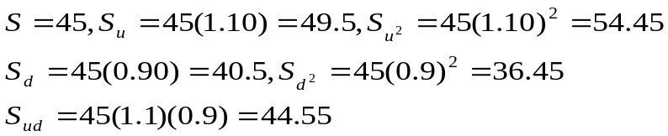
  - Determine the possible prices of the call at expiration.
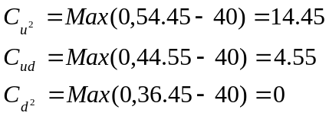
  - Find the possible prices of the call at the end of the first period.
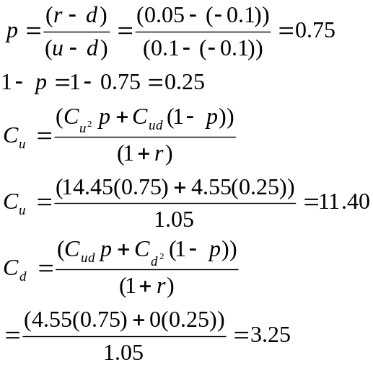
  - What is the current price of the call?
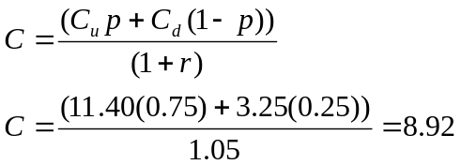
  - What is the initial hedge ratio?
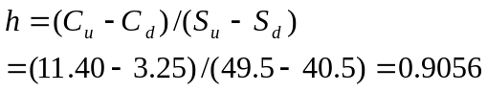
  - What are the two possible hedge ratios at the end of the first period?
If the stock goes up
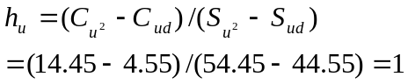

If the stock goes down
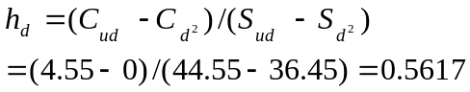

  - Construct an example showing that the hedge works. Make sure the example illustrates how the hedge portfolio earns the risk free rate over both periods.
Buy 906 shares and write 1,000 calls
Value of portfolio today:
906(45)-1,000(8.92) = 31,850
Value of portfolio one period later:
If stock goes up,
906(49.50)-1,000(11.40)=33,447
If the stock goes down,
906(40.50)-1,000(3.25)=33,443
These two amounts are essentially equivalent.
Return over one period = (33,447 / 31,850)-1 0.05
If the stock goes up to 49.5, h_{u} =1. Then buy 94 calls at 11.40 for $1,072. Borrow the money at the risk-free rate. Now you have 906 shares and 906 calls, which is a hedge ratio of 1. Your portfolio is:
906 shares at 49.50 = 44,847
-906 calls at 11.40 = -10,328
-loan = -1,072
33,447
Value of portfolio one period later

If stock goes up,
906(54.45)-906(14.45)-1,072(1.05) = 35,114
If stock goes down,
906(44.55)-906(4.55)-1,072(1.05) = 35,114
If the stock had gone down in the first period to 40.50, then h_{d} =0.562. Then sell 344 shares at 40.50. Take the proceeds of 13,932 and invest this amount for the next period in risk-free bonds earning 5 percent. Now you have 562 shares and 1,000 calls, which is a hedge ratio of 0.562. Your portfolio is:
562 shares at 40.50 = 22,761
-1000 calls at 3.25 = -3,250
Bonds = 13,932
33,443
Value of the portfolio at the end of the second period:
If the stock goes up,
562(44.55)-1,000(4.55)+13,932(1.05)=35,116
If the stock goes down,
562(36.45)+13,932(1.05)=35,114
The difference between 35,114 and 35,116 is due to rounding.
Return over two periods = 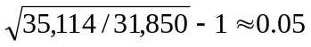
  - What would an investor do if the call were overpriced? If it were underpriced?
If it were overpriced, the investor should establish the same risk-less hedge by buying 906 shares and writing 1,000 calls. If it were underpriced, the investor should buy 1,000 calls and sell short 906 shares. This would create a type of loan in which money is received today and paid back later. The effective rate on the loan would be less than the risk-free rate.
- Consider the following binomial option pricing problem involving an American call. This call has two periods to go before expiring. Its stock price is 30, and its exercise price is 25. The risk free rate is 0.05. The value of u is 0.15 and the value of d is -0.1. The dividend yield is 0.06. Find the value of the call.
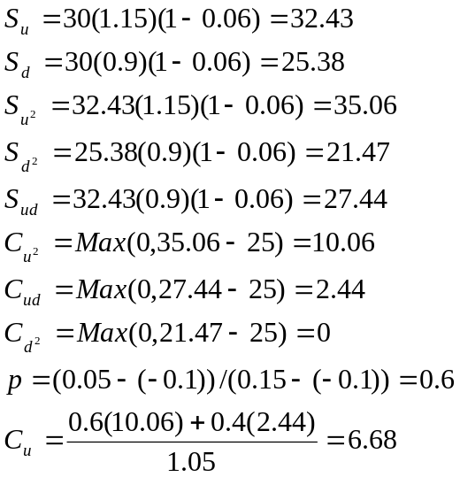
But worth 32.43-25 = 7.43 if exercised so C_{u} = 7.43
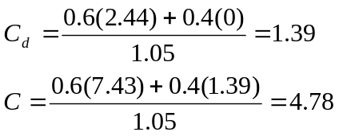
But worth 30-25 = 5 if exercised so C = 5

The following option prices were observed for calls and puts on a stock for the trading day of July 6 of a particular year. Use this information in problems 12 through 20. The stock was priced at 165 1/8. The expirations were July 17, August 21, and October 16. The continuously compounded risk-free rates associated with the three expirations were 0.0503, 0.0535, and 0.0571, respectively. Unless otherwise indicated assume the options are European.
Strike | Calls |  |  | Puts
Strike | July | Aug | Oct | Jul | Aug | Oct
155 | 10.5 | 11.75 | 14 | 0.1875 | 1.25 | 2.75
160 | 6 | 8.125 | 11.125 | 0.75 | 2.75 | 4.5
165 | 2.6875 | 5.25 | 8.125 | 2.375 | 4.75 | 6.75
170 | 0.8125 | 3.25 | 6 | 5.75 | 7.5 | 9

- Let the standard deviation of the continuously compounded return on the stock be .21. Ignore dividends. Answer the following:
  - What is the theoretical fair value of the Oct 165 call? Calculate this answer by hand and then recalculate it using either bsbin1.xls or bsbwin2.exe.
S = 165.125 E = 165 r_{c} = 0.0571 σ=0.21 T=0.2795 (102 days from 7/6 to 10/16)
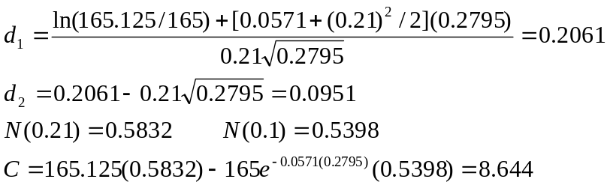
Using bsbin1.xls, you should obtain approximately 8.6999. using bsbwin2.exe, you should obtain approximately 8.6980.
  - Based on your answer in part a, recommend a riskless strategy.
The actual price is 8.125. The call appears to be underpriced. We should buy 1,000 calls and sell short 1,000(0.583)=583 shares and revise the hedge continuously so that the proper ratio of calls to shares is maintained.
  - If the stock price decreases by $1, how will the option position offset the loss on the stock?
For each dollar change in the stock price, the option price changes by approximately the value of N(d₁), its delta, of 0.583. So if 583 shares that were sold short decrease in value by one dollar, the gain is $583, but the 1,000 calls will decrease in value by $0.583 each. Since we are long the calls, we lose $583 on the calls. Thus, the loss on the long calls should be offset by the gain on the short stock.
- Use the Black-Scholes European put option pricing formula for the October 165 put option. Repeat parts a, b, and c of question 12 with respect to the put.
a) We have
Using bsbin1.xls, you should obtain approximately 5.9625. Using bsbwin2.exe, you should obtain approximately 5.9606.
b) The put appears to be overpriced at 6.75. You should sell 1,000 puts and sell short –(0.5832-1) 1,000 = 417 shares. However, we should note that in reality the put might not be overpriced since the Black-Scholes model does not account for the privilege of early exercise.
c) We would gain $417 by being short 417 shares. We would lose $417 on the puts because we are short 1,000 puts that increase in value by $0.417 each. Thus, the loss on the short puts is exactly offset by the gain on the short stock.
- Suppose the stock pays a $1.1 dividend with an ex-dividend date of Sep 10. Rework part a of problem 12 using an appropriate dividend adjusted procedure. Calculate this answer by hand and then recalculate it using either bsbin1.xls or bsbwin2.exe.
The time to the ex-dividend date is 66 days, so t = 66/365 = 0.1808. We adjust the stock price to
Inserting into the Black-Scholes model, we have
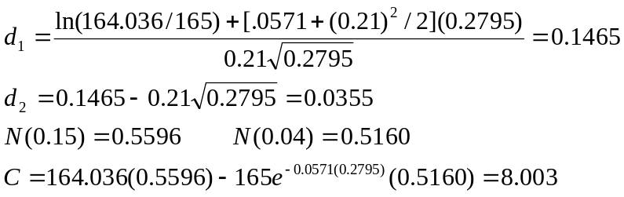
Using bsbin1.xls you should obtain 8.0794. Using bsbwin2.exe, you should obtain approximately 8.0786.
- On July 6, the dividend yield on the stock is 2.7%. Rework part a of problem 12 using the yield based dividend adjustment procedure. Calculate this answer by hand and then recalculate it using either bsbin1.xls or bsbwin2.exe.
We adjust the stock price to
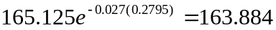
Inserting into the Black-Scholes model, we have
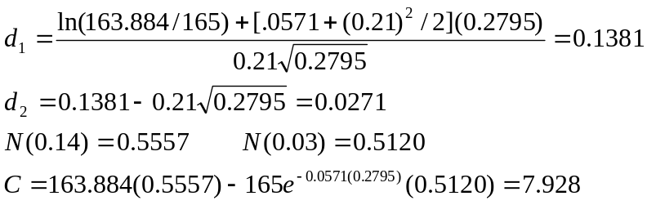
Using bsbin1.xls you should obtain 7.9944. Using bsbwin2.exe, you should obtain approximately 7.9939.

- Suppose on July 7 the stock will go ex-dividend with a dividend of $2. If the options were American, determine whether the July 160 call would be exercised.
On July 7 there will be 10 days remaining so the time to expiration will be 10/365 = 0.0274. As soon as the stock goes ex-dividend, its price will fall to 163.125. Then the options price will be
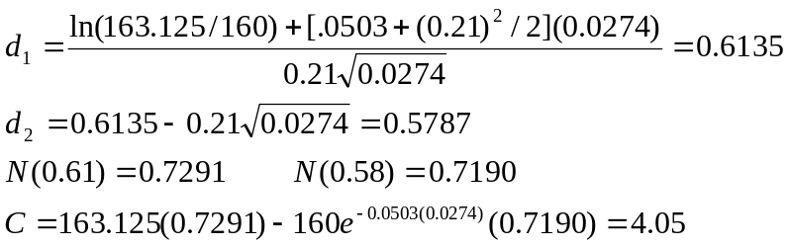
Exercise just before the stock goes ex-dividend would net 165.125-160 = 5.125 so you should exercise.

- Following is the sequence of daily prices on the stock for the preceding month of June:

Date | Price | Date | Price
6/1 | 159.875 | 6/16 | 162.000
6/2 | 157.250 | 6/17 | 161.375
6/3 | 160.250 | 6/18 | 160.875
6/4 | 161.375 | 6/19 | 161.375
6/5 | 160.000 | 6/22 | 163.250
6/8 | 161.250 | 6/23 | 164.875
6/9 | 159.875 | 6/24 | 166.125
6/10 | 157.750 | 6/25 | 167.875
6/11 | 157.625 | 6/26 | 166.500
6/12 | 156.625 | 6/29 | 165.375
6/15 | 159.625 | 6/30 | 162.500

Estimate the historical standard deviation of the stock for use in the Black-Scholes model. ((Ignore dividends on the stock)

Date | Price | R | R^{c}=ln(1+R) | (R^{c} - Mean)²
6/1 | 159.875
6/2 | 157.25 | -0.01642 | -0.01656 | 0.00030
6/3 | 160.25 | 0.01908 | 0.01890 | 0.00033
6/4 | 161.375 | 0.00702 | 0.00700 | 0.00004
6/5 | 160 | -0.00852 | -0.00856 | 0.00009
6/8 | 161.25 | 0.00781 | 0.00778 | 0.00005
6/9 | 159.875 | -0.00853 | -0.00856 | 0.00009
6/10 | 157.75 | -0.01329 | -0.01338 | 0.00020
6/11 | 157.625 | -0.00079 | -0.00079 | 0.00000
6/12 | 156.625 | -0.00634 | -0.00636 | 0.00005
6/15 | 159.625 | 0.01915 | 0.01897 | 0.00033
6/16 | 162 | 0.01488 | 0.01477 | 0.00020
6/17 | 161.375 | -0.00386 | -0.00387 | 0.00002
6/18 | 160.875 | -0.00310 | -0.00310 | 0.00002
6/19 | 161.375 | 0.00311 | 0.00310 | 0.00001
6/22 | 163.25 | 0.01162 | 0.01155 | 0.00012
6/23 | 164.875 | 0.00995 | 0.00990 | 0.00008
6/24 | 166.125 | 0.00758 | 0.00755 | 0.00005
6/25 | 167.875 | 0.01053 | 0.01048 | 0.00009
6/26 | 166.5 | -0.00819 | -0.00822 | 0.00008
6/29 | 165.375 | -0.00676 | -0.00678 | 0.00006
6/30 | 162.5 | -0.01738 | -0.01754 | 0.00034
 |  | Total | 0.01629 | 0.00253
 | Mean = | 0.01629 / 21 | 0.00078
 | σ² = | 0.00253 / 20 | 0.000126
 | σ = | 0.011240 | (This is daily standard deviation)
 | σ annualized= | 0.01124(250)^{1/2} | =0.1777

- Estimate the implied volatility of the Aug 165 Call. Compare your answer with that obtained in problem 17. Use trial and error. Stop when your answer is with 0.01 of the true implied volatility. Use the excel spread sheet bsbin1.xls or the windows program bsbwin2.exe.
At σ=0.20, the Black-Scholes price is approximately 5.30. At σ=0.19, the Black Scholes price is approximately 5.07. The implied volatility is, therefore, between 19 and 20 percent. This is slightly higher than the historical volatility obtained in problem 17, meaning that the volatility has recently increased.
- Repeat problem 18 using the approximation for an at-the-money call. Compare your answer with the one you obtained in problem 18. Is the approximation a good one?
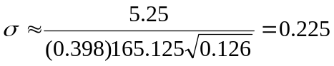
It is a little high but provides a good starting point. Of course, the call is slightly in the money any way. So the estimate will tend to be a little off.
- In problem 12, you estimated the value of Oct 165 call using the Black-Scholes model. Now estimate the value of that option using the binomial model for 1, 5, 10, 25, and 50 time periods. Use the excel spread sheet bsbin1.xls or the windows program bsbwin2.exe.
These calculations were obtained using bsbin1.xls.
For 1-time period C = 10.4586
For 5-time periods C = 9.0568
For 10-time periods C = 8.5342
For 25-time periods C = 8.7703
For 50-time periods C = 8.6701

- (Concept Problem) Find the value of an American put option using the binomial option pricing model. The parameters are S=62, E=70, r=0.08, u=0.1 and d=-0.05. There are no dividends. Use n=2 periods.
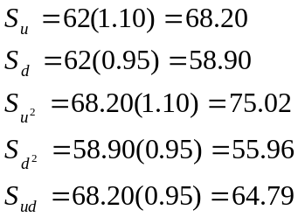

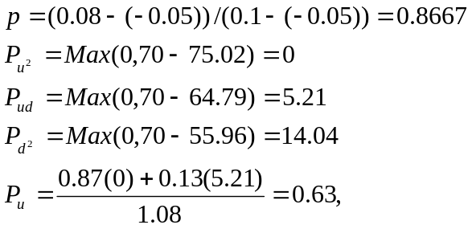
But worth Max(0,70-68.2)=1.80 if exercised. So P_{u} = 1.80

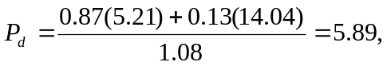
But worth Max(0,70-58.90)=11.10 if exercised. So P_{d} = 11.10.

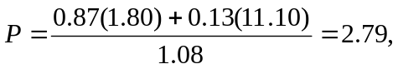
But worth Max(0,70-62)=8 if exercised. So P=8.

- (Concept Problem) Find the value of a European call option using the Black Scholes option pricing model. The parameters are S=80, E=80, r_{c} =0.05, σ=0.35 and T=0.25. Determine the Delta and estimate the change in the call price if the stock goes to the following prices; 70, 75, 78, 79, 81, 82, 85, 90. Then compute the Black-Scholes values for each of these new stock prices. Compare your estimates with the actual prices, and comment on the differences. Use the excel spread sheet bsbin1.xls or the windows program bsbwin2.exe.
Using the Black-Scholes model
C=6.0544 N(d₁) = 0.5631

The new call price is estimated as OLD CALL PRICE PLUS (STOCK PRICE CHANGE) (DELTA).
The actual call price is found by recomputing the Black-Scholes model.
New stock Price | Estimated New Call Price | Actual New Call Price | Difference
70 | 0.4234 | 1.8820 | 1.4586
75 | 3.2389 | 3.6010 | 0.3621
78 | 4.9282 | 4.9852 | 0.0570
79 | 5.4913 | 5.5055 | 0.0142
81 | 6.6175 | 6.6315 | 0.0140
82 | 7.1806 | 7.2360 | 0.0554
85 | 8.8699 | 9.2051 | 0.3352
90 | 11.6854 | 12.9436 | 1.2582

The estimates are far more accurate for small stock price changes.

Chapter 5

Questions and Problems and Answers

- Explain the advantages and disadvantages to a call buyer of closing out a position prior to expiration rather than holding all the way until expiration.
When a call is purchased, the buyer pays for both the time value and intrinsic value of the option. As the call gets closer and closer to expiration, it will lose its time value. At expiration of the call, the holder collects only the intrinsic value. By selling the call prior to expiration, the holder is able to recover some of the time value previously purchased. For a given stock price, this increases the profit or decreases the loss; however, the shorter the holding period, the less time the stock price has to move upward. The tradeoff in deciding whether to sell an option early is between cutting the loss of time value and giving the stock enough time to make a substantial move.
- Suppose one is considering buying a call at a particular exercise price. What reasons could be given for the alternative of buying a call at a higher exercise price? At a lower exercise price?
The call with a higher exercise price will be far more speculative, because the stock price must go higher in order to break even; however, the premium on such a call will be lower. A call with a lower exercise price will have a greater chance of expiring in the money; however, the premium will be higher. The tradeoff is between taking a gamble on the call with a higher exercise price at the cost of a small premium or buying the safer call with a lower exercise price at the cost of a larger premium.
- Explain how a protective put is like purchasing insurance on a stock.
A protective put establishes a minimum price at which a stock can be sold. In a bear market, the stock will lose value that can be recovered by exercising the put. This makes the put like an insurance policy that pays off in the event of a loss. The premium on the put is like the premium on the insurance policy. If the price of the stock goes up, the insurance is not needed, so the put is allowed to expire.
- Why is the choice of exercise price on a protective put like the decision on which deductible to take on an insurance policy?
The higher the exercise price, the higher the price at which the stock can be sold. This reduces the overall loss in a bear market, but, of course, will require a higher premium. It is, therefore, like taking a lower deductible in an insurance policy. By forcing the insurer (the put writer) to assume more of the potential loss, the cost of the insurance (the put premium) rises.
- Discuss and compare the two bullish strategies of buying a call and writing a put. Why would one strategy be preferable to the other?
Both strategies are indeed bullish. Buying a call gives you the option to buy the stock at a favorable price. Writing a put on the other hand, gives you the obligation to buy the stock at what might be an unfavorable price. Both the call buyers and put writer will profit in a bull market, but the call buyer will do better in a strong bull market because the profit will be higher the higher the stock price. The put writer’s profit is limited to the original premium received. In a bear market, the call buyer will have limited losses while the put writer will lose more the lower the stock price. All of this makes it sound as though the call buyer does better than the put writer, but this is not necessarily so. The call buyer is paying a premium while the put writer is receiving a premium. The put writer earns interest on the premium while the call buyer forgoes interest.
- Suppose you wish to buy stock and protect yourself against a downside movement in its price. You consider both a covered call and a protective put. What factors will affect your decision?
The covered call cuts losses on the downside and gains on the upside. In a bull market, the call is likely to be exercised and the stock called away. This limits the gain in a bull market to the amount of the premium plus the difference between the exercise price and the original stock price. A protective put cuts losses in a bear market but does allow gains in a bull market, which are higher the higher the stock price. Since a protective put is a synthetic call, the comparison is more appropriately seen as that of writing a covered call versus buying a call. Should we own stock and protect it with a short call or own simply the call? Both strategies are bullish, but the call (or protective put) would appeal more in situations where the investor is more concerned about taking advantage of a bull market than providing protection in a bear market.
- You have inherited some stock from a rich relative. The stock has had poor performance recently, and analysts believe it has little growth potential. You would like to write calls against the stock; however, the will stipulates that you must agree not to sell it unless you need the funds for a personal financial emergency. How can you write covered calls and minimize the likelihood of exercise?
You could concentrate on writing out-of-the-money calls; however, this would not guarantee that the stock would not be called away. The position must be carefully monitored. If the call moves in-the-money, it could be repurchased. Then you should write another out-of-the-money call. If the stock price continues to move upward, you continue to roll out of one exercise price into a higher exercise price. Disadvantages of this strategy are the potential for generating higher transaction costs and the trouble of monitoring the portfolio, as well as the fact that writing out-of-the-money calls produces relatively small premiums.
- We briefly mentioned the synthetic call, which consists of stock and an equal number of puts. Assume the combined value of the puts and stock exceeds the value of the actual call by less than the present value of the exercise price. Show how an arbitrage profit can be made. Note; do not use the data from the chapter. Show your point as it was illustrated in the text for the synthetic put.
If 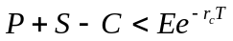, then the synthetic call (put+stock) is underpriced or the actual call is overpriced. So buy the synthetic call and sell the actual call. The payoffs from this portfolio at the expiration are
 | S_{T} < = E | S_{T} > E
Short call | 0 | -(S_{T} – E)
Long stock | S_{T} | S_{T}
Long put | (E - S_{T} ) | 0
Total | E | E

The cost of this portfolio is P+S-C, which we said was less than the present value of the exercise price. So we are essentially buying a portfolio that pays off E dollars for certain and paying a price that is less than the present value of E.
- A short position in stock can be protected by holding a call option determine the profit equations for this position, and identify the breakeven stock price at expiration and maximum and minimum profits.
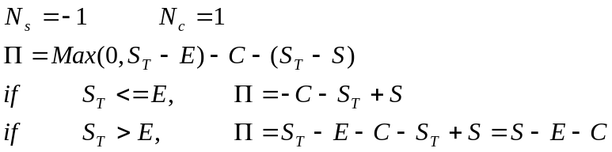
The breakeven is at a value of S_{T} <= E. Setting this profit equation to zero
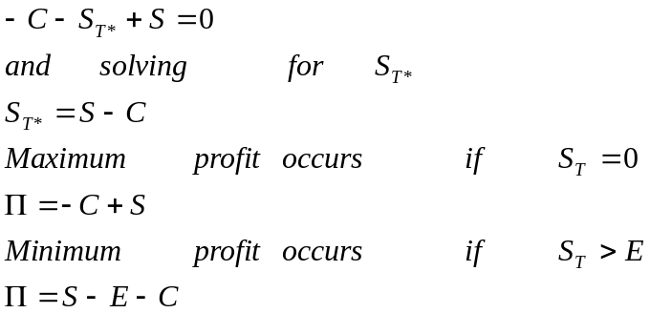
Which is negative since C must be greater than S-E
- A short stock can be protected by selling a put. Determine the profit equations for this position, and identify the breakeven stock price at expiration and maximum and minimum profits.
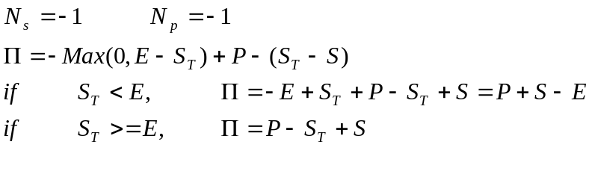
The breakeven is at a value of S_{T} > E. Setting this profit equation to zero
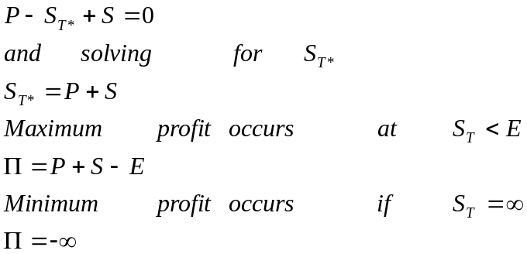

- Explain the advantages and disadvantages to a covered call writer of closing out the position prior to expiration.
Time value is directly related to time to expiration. If the covered writer closes out the position prior to the expiration, the call will be more expensive to repurchase. This reduces the profit for a given stock price. However, the shorter the holding period, the less time the stock price has to move downward. Writers of options benefit from short holding periods by giving the stock less time to move, but they have to buy back more of the original time value they received.
- Explain the considerations facing a covered call writer regarding the choice of exercise prices.
The lower the exercise price, the more protection the option is providing. This is because the call with the lower exercise price commands a higher premium and the premium cushions the loss on the downside. The disadvantage of a lower exercise price is that the option is more likely to be exercised and the upside gain is lower.

The following option prices were observed for a stock for July 6 of a particular year. Use this information in problems 13 through 18. Ignore dividends on the stock. The stock is priced at 165 1/8. The expirations are July 17, Aug 21, and Oct 16. The continuously compounded risk-free rates are 0.0503, 0.0535, and 0.0571 respectively. The standard deviation is 0.21. Assume the options are European.

Strike | Calls |  |  | Puts
Strike | July | Aug | Oct | Jul | Aug | Oct
165 | 2 11/16 | 5 ¼ | 8 1/8 | 2 3/8 | 4 ¾ | 6 ¾
170 | 13/16 | 3 ¼ | 6 | 5 ¾ | 7 ½ | 9

In problems 13 through 18, determine the profits for possible stock prices of 150, 155, 160, 165, 170, 175, and 180. Answer any other question as requested. Note; your excel spread sheet stratlyz1.xls will be useful here for obtaining graphs as requested, but it does not allow you to calculate the profits for several user-specified asset prices. It permits you to specify one asset price and a maximum and minimum. Use stratlyz1.xls to produce the graph for the range of prices from 150 to 180 but determine the profits for the prices of 150, 160, ……, 180 by hand for positions held to expirations. For positions closed prior to expirations, use the spreadsheet bsbin1.xls or the windows program bsbwin2.exe to determine the option price when the position is closed; then calculate the profit by hand.

- Buy one August 165 call contract. Hold until the option expires. Determine the profits and graph the results. Then identify the breakeven stock price at expiration. What is the maximum possible loss on this transaction?

C = 5.25

S_{T} | Call Price at | Profit
 | expiration
150 | 0 | -525
155 | 0 | -525
160 | 0 | -525
165 | 0 | -525
170 | 5 | -25
175 | 10 | 475
180 | 15 | 975

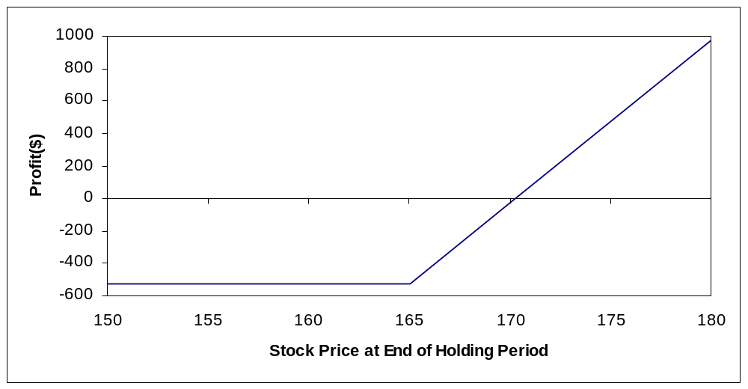

Breakeven: E + C = 165+5.25=170.25
Maximum Loss: 525 (the premium)

- Repeat problem 13, but close the position on August 1. Calculate the profit by hand when the stock price on August 1 is 155. Then use the spreadsheet or calculate by hand to find the profits for the possible stock prices on August 1. Generate a graph and use it to identify the approximate breakeven stock price.
E = 165 r_{c} = 0.0535 σ=0.21 C=5.25
T₁ = 20/365 = 0.0548 (based on 20 days between 8/1 and 8/21)
By hand with S_{T} = 155,
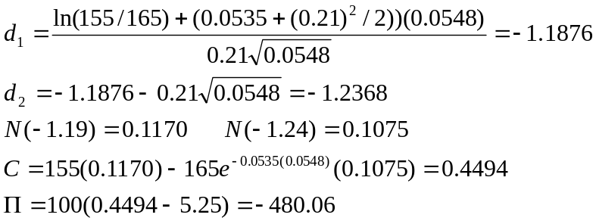
The results using a spread sheet are

S_{T} | Call Price at end | Profit
 | of Holding Period
150 | 0.0901 | -515.99
155 | 0.4295 | -482.05
160 | 1.4203 | -382.97
165 | 3.4782 | -177.18
170 | 6.7247 | 147.47
175 | 10.8992 | 564.92
180 | 15.5951 | 1034.51

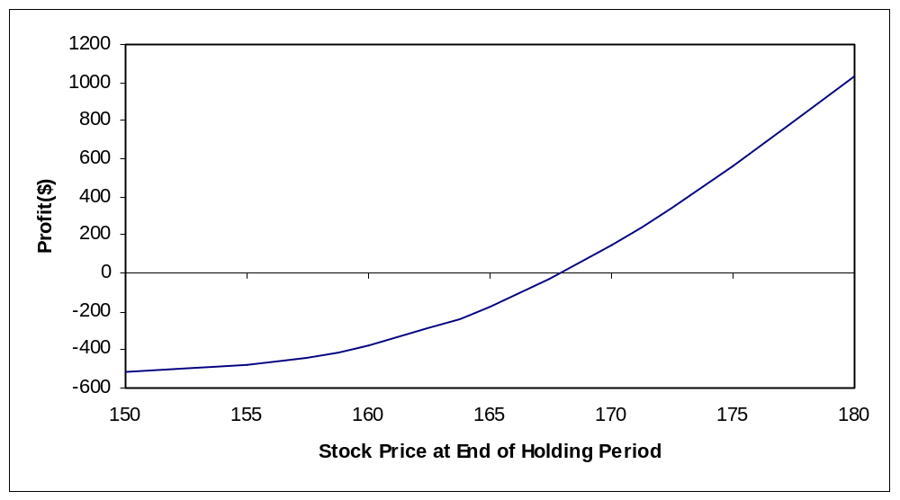

Breakeven stock price: approximately 168
Maximum loss: 525 (the premium)

- Buy one October 165 put contract. Hold until the options expire. Determine the profits and graph the results. Then identify the breakeven stock price at expiration. What are the maximum possible gain and loss on this transaction?

P= 6.75

S_{T} | Put Price at | Profit
 | Expiration
150 | 15 | 825
155 | 10 | 325
160 | 5 | -175
165 | 0 | -675
170 | 0 | -675
175 | 0 | -675
180 | 0 | -675

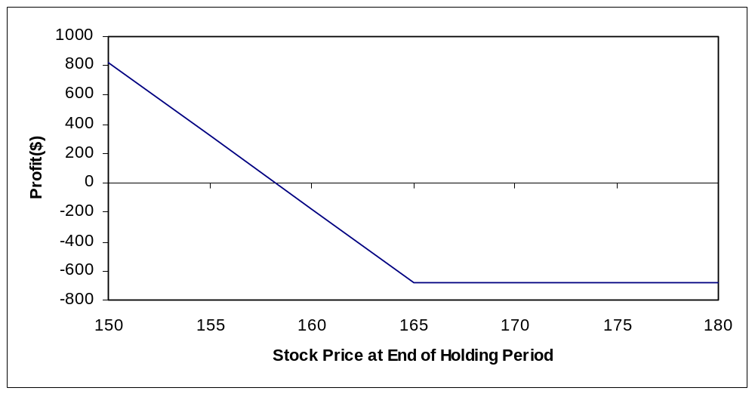

Breakeven: E-P = 165 – 6.75 =158.25
Maximum Loss: 675
Maximum gain (if S_{T} = 0) : 15,825

- Buy 100 shares of stock and write one October 170 call contract. Hold the position until expiration. Determine the profits and graph the results. Identify the breakeven stock price at expiration, the maximum profit, and the maximum loss?
C = 6

S_{T} | Call Price at | Profit | Profit | Overall
 | Expiration | from Call | from Stock | Profit
150 | 0 | 600 | (1,512.15) | (912.15)
155 | 0 | 600 | (1,012.50) | (412.50)
160 | 0 | 600 | (512.50) | 87.50
165 | 0 | 600 | (12.50) | 587.50
170 | 0 | 600 | 487.50 | 1,087.50
175 | 5 | 100 | 987.50 | 1,087.50
180 | 10 | -400 | 1,487.50 | 1,087.50

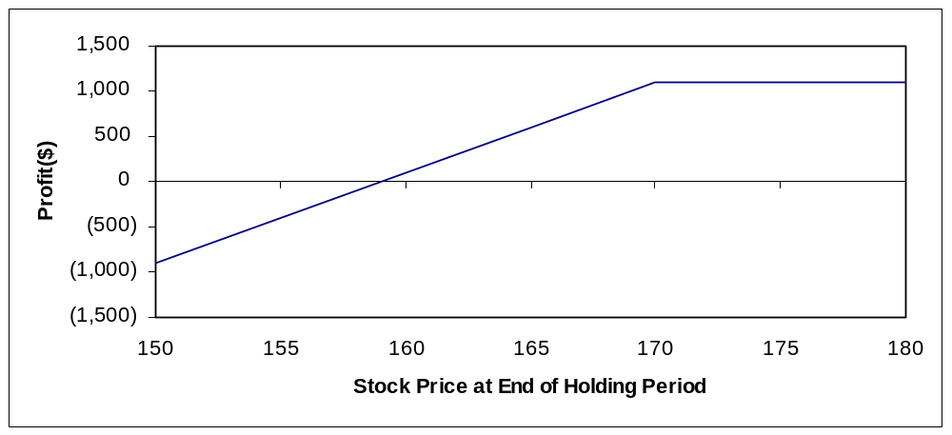

Breakeven: S-C = 165.125 – 6 =159.125
Maximum profit: 1,087.50
Maximum loss (if S_{T} = 0) :
Profit from Call = 600
Profit from Stock = -16,512.50
Overall Profit = -15,912.50

- Repeat problem 16, but close the position on September 1. Calculate the profit by hand when the stock price on September 1 is 155. Then use the spreadsheet or calculate by hand to find the profits for the possible stock prices on September 1. Generate a graph and use it to approximate the breakeven stock price.
E = 170 r_{c} = 0.0571 σ=0.21 C=6
T₁ = 45/365 = 0.1233 (based on 45 days from 9/1 to 10/16)
By hand with S_{T} = 155,
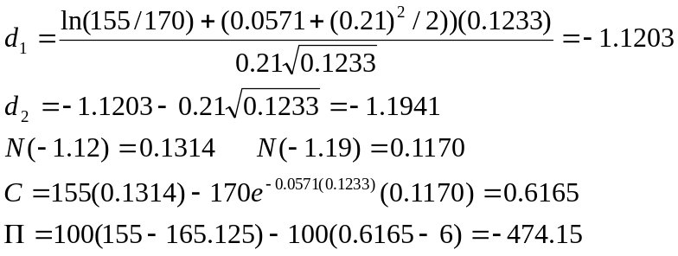
The results using a spread sheet are
S_{T} | Call Price at | Profit | Profit | Overall
 | end of Holding Period | from Call | from Stock | Profit
150 | 0.2714 | 572.86 | (1,512.50) | (939.64)
155 | 0.7297 | 527.03 | (1,012.50) | (485.47)
160 | 1.654 | 434.6 | (512.50) | (77.90)
165 | 3.2381 | 276.19 | (12.50) | 263.69
170 | 5.6014 | 39.86 | 487.50 | 527.36
175 | 8.7436 | -274.36 | 987.50 | 713.14
180 | 12.554 | -655.4 | 1,487.50 | 832.10

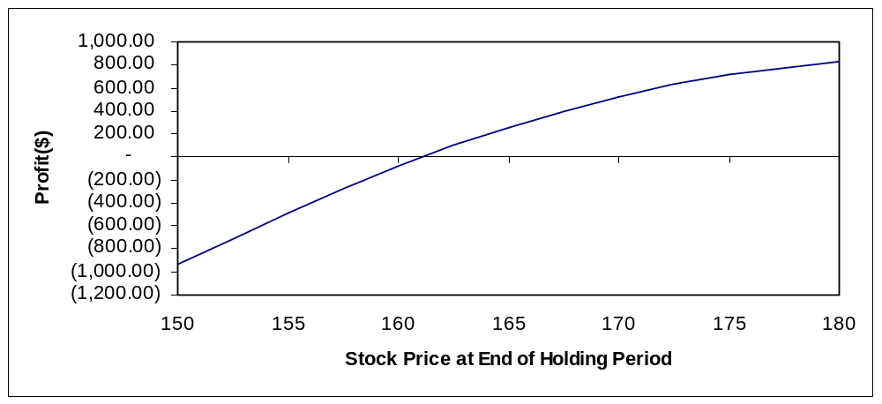

Breakeven stock price 162

- Buy 100 shares of stock and buy one August 165 put contract. Hold the position until expiration. Determine the profits and graph the results. Determine the breakeven stock price at expiration, the maximum profit, and the maximum loss.

P = 4.75

S_{T} | Put Price at | Profit | Profit | Overall
 | Expiration | from Put | from Stock | Profit
150 | 15 | 1025 | (1,512.50) | (487.50)
155 | 10 | 525 | (1,012.50) | (487.50)
160 | 5 | 25 | (512.50) | (487.50)
165 | 0 | -475 | (12.50) | (487.50)
170 | 0 | -475 | 487.50 | 12.50
175 | 0 | -475 | 987.50 | 512.50
180 | 0 | -475 | 1,487.50 | 1,012.50

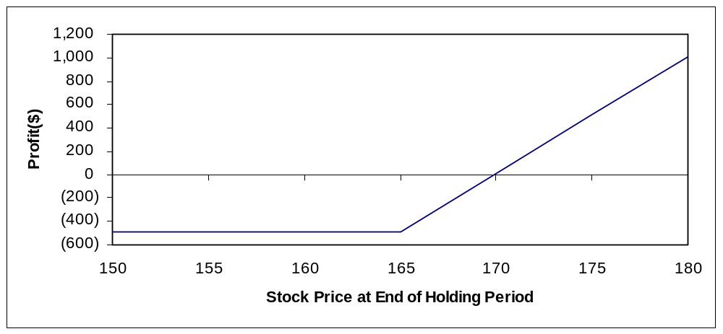

Breakeven: P+S = 4.75 + 165.125 = 169.875
Maximum Profit:
Maximum Loss : 487.50

- (Concept Problem) In each case examined in the chapter and in the preceding problems, we did not account for the interest on funds invested. One useful way to observe the effect of interest is to look at a conversion or a reverse conversion. Evaluate the August 165 puts and calls, and recommend a conversion or a reverse conversion. Determine the profit from the transaction if the options are held to expiration. Make sure the profit properly accounts for the interest that accrues over the holding period.

This is a reverse conversion.

Sell Put +4.75
Buy Synthetic Put
Buy Call -5.25
Sell stock +165.125
Net cash in 164.625

Invest at 5.35% to grow to 164.625 (1.0535)^{0.1260} = 165.71

Amount owed at expiration = 165

Net gain = 0.71

- (Concept Problem) Another consideration in evaluating option strategies is the effect of transaction costs. Suppose purchases and sales of an option incur a brokerage commission of 1 percent of the option’s value. Purchases and sales of a share of stock incur a brokerage commission of 0.5 percent of the stock’s value. If the option is exercised, there is a transaction cost on the purchase or sale of the stock. Determine the profit equations for the following strategies assuming the options are held to expiration and exercised if in-the-money rather than sold back. Assume that one option and / or share is used and that any shares left in the portfolio are sold.
  - Long call
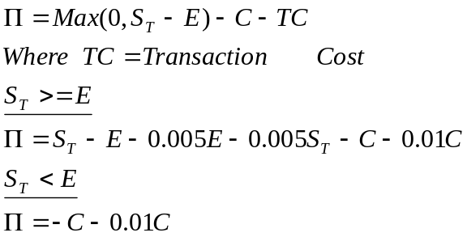
  - Long put
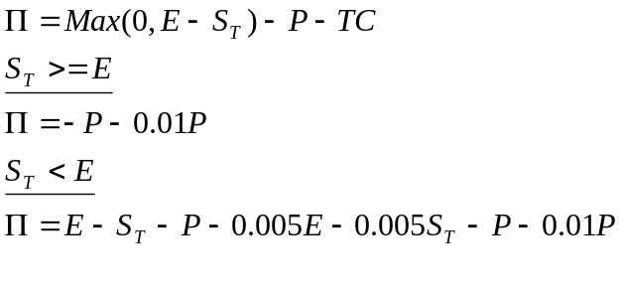
  - Covered call
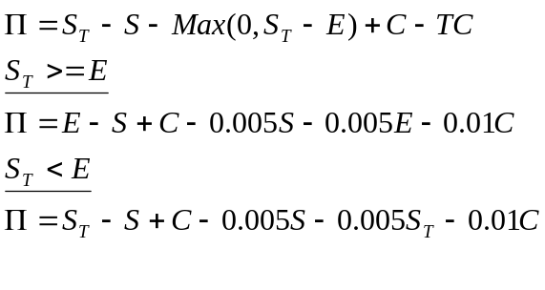

  - Protective put
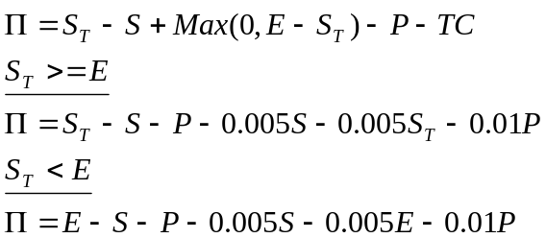

Chapter 6

Questions and Problems and Answers

- Explain why option traders often use spreads instead of simple long or short options and combined positions of options and stock.
Simple long or short positions expose the trader to considerable risk. This is especially true for short positions. By taking an opposite position in another option, i.e. , executing a spread, the trader is able to keep the risk to a more manageable level. Combined positions of options and stocks do the same thing, the options serves as a hedge for the stock or the stock serves as a hedge for the option. However, a position in both options and stock is harder to execute since the options and stocks trade in different markets. This results in time delays in getting the trades executed. On the other hand, a spread can be executed much faster, with both transactions done almost simultaneously in the same market.
- Suppose an option trader has a call bull spread. The stock price has risen substantially, and the trader is considering closing the position early. What factors should the trader consider with regard to closing the transaction before the options expire?
Since the stock price is closer to the higher exercise price than to the lower exercise price, the short call at the higher exercise price has the greater time value. Therefore, holding the position longer could result in a greater time value decay on the short call than on the long call. This will occur only, however, if the stock price does not move down. The cross-over point indicated in figure 6.2 in the chapter is a critical stock price below which a shorter holding period is preferred. If it appears as if the stock price will fall below the cross-over stock price, the position should be closed as soon as possible, but only if the stock price is not expected to turn back around before the option expires.
- Suppose you are following the stock of a firm that has been experiencing severe problems. Failure is imminent unless the firm is granted government guaranteed loans. If the firm fails, its stock will, of course, fall substantially. If the loans are granted, it is expected that the stock will rise substantially. Identify two strategies that would be appropriate for this situation. Justify your answers.
Both a straddle and a time spread can be used in this situation. A straddle consisting of the purchase of a put and a call with identical exercise prices and expirations would profit if the stock price move substantially in either direction. A time spread consisting of the sale of a longer-term option and the purchase of a shorter-term option would also profit if the stock price move significantly in either direction. This is because a large stock price move will allow repurchase of the longer term options when it has little time value remaining. Note that this example is the opposite of the one discussed in the text. Also, a butterfuly spread that is short the high and low exercise prices and long two of the middle exercise price could be used in this situation, but it would have limited gains if the stock price moved substantially.
- Explain why in some situations a put bear spread could offer an advantage over a similar call bear spread.
A put bear spread could offer two advantages over a call bear spread. First, it is possible that the puts could be mispriced while the calls are correctly priced. Second, a call bear spread runs the risk of early exercise. The short call can be in-the-money without the long call also being in-the-money. For the put bear spread, however, the short put will not be in-the-money unless the long put is also. Then if the short put is exercised, the long put can be exercised for a net gain of – (E₁ – S_{t} ) + (E₂ – S_{t} ) = E₂ - E₁ which is the maximum value that could be expected by holding the position to expiration.
- Derive the profit equations for a put bull spread. Determine the maximum and minimum profits and the breakeven stock price at expiration.
Buy one put with exercise price E₁ and sell one put with exercise price E₂.
The profit equation is
Π = Max (0, E₁ – S_{T} ) - P₁ - Max(0, E₂ – S_{T} ) + P₂
If S_{T} < E₁ < E₂
Π = E₁ – S_{T} - P₁ - E₂ + S_{T} + P₂
= E₁ – E₂ - (P₁ - P₂)
Recall form chapter 3 that the difference between the exercise prices is less than the difference between premiums. Since E₁ < E₂ and P₁ < P₂, the above profit is negative.

If E₁ < S_{T} < E₂
Π = - P₁ - E₂ + S_{T} + P₂

This figure increases dollar for dollar with S_{T} . The breakeven is found by setting the profit to zero,
- P₁ - E₂ + S_{T} * + P₂ = 0
And solving for S_{T} *
S_{T} * = E₂ +(P₁ - P₂ )

If E₁ < E₂ < = S_{T}
Π = - P₁ + P₂

Since P₂ > P_{1,} this figure is positive.

The minimum profit occurs in the first profit range, S_{T} < E₁ < E₂ and equals E₁ – E₂ - (P₁ - P₂). The maximum profit occurs in the third profit range, E₁ < E₂ < = S_{T} and equals - P₁ + P₂

- Explain the process by which the profit of a short straddle closed out prior to expiration is influenced by the time values of the put and call.
First note that the graph for a short straddle held to expiration is an inverted V. If closed out prior to expiration, a short straddle ( which involves the sale of both a put and a call) will require the repurchase of both options. This means that prior to expiration, there will be time values on both the put and the call that will have to be repurchased. These time values are highest if the stock price is close to the exercise price. So the profit if the stock price is near the exercise price is lower the shorter the holding period. The longer the investor can hold the position, the less time value that remains on the options. However, this also gives the stock more time to move substantially and potentially generate a large loss.
- Explain why selecting a strap over a straddle implies a slightly more bullish outlook.
If the investor feels that the market is as likely to go down as up, a straddle would be an appropriate strategy because the profit graph is symmetric. If the investor feels slightly more bullish than bearish, then the addition of a second call enables the investor to capitalize if the market goes up. However, the cost of the second call must be recovered, and in a strong bear market or one in which the stock price does not move much in either direction, the cost of the second call cuts significantly into the profit. A strap is like placing more money on the line that the market will go up. Unless you are right and the market goes up enough to enable you to exercise or sell the calls and recover the premiums paid, then your profit will be lower.
- The chapter showed how analyzing a box spread is like a capital budgeting problem using the net present value approach. Consider the internal rate of return method of examining capital budgeting problems and analyze the box spread in that context.
In internal rate of return (Capital IRR) problems, the return from the investment is compared to the opportunity cost of capital. The investment is acceptable if the IRR exceeds the opportunity cost. In the box spread problem, the investment pays E₂ - E₁ . The initial outlay is C₁ - C₂ – P₁+ P₂ . The IRR is the value of i that solves
(E₂ - E₁ ) (1 + i )^{-T} = C₁ - C₂ – P₁+ P₂
The opportunity cost is the risk-free rate, r . If i is greater than r, then the box spread is acceptable. If i is less than r, then the box spread is overpriced and should be reversed.
The following option prices were observed for calls and puts on a stock on July 6 of a particular year. Use this information for problems 9 through 21. The stock was priced at 165 1/8. The expirations are July 17, August 21, October 16. The continuously compounded risk-free rates associated with the three expirations are 0.0503, 0.0535, 0.0571, respectively. The standard deviation is 0.21.

Strike | Calls |  |  | Puts
Strike | July | Aug | Oct | Jul | Aug | Oct
160 | 6 | 8 1/8 | 11 1/8 | ¾ | 2 ¾ | 4 ½
165 | 2 11/16 | 5 ¼ | 8 1/8 | 2 3/8 | 4 ¾ | 6 ¾
170 | 13/16 | 3 ¼ | 6 | 5 ¾ | 7 ½ | 9

For problems 9 through 12 and 15 through 18, determine the profits for the holding period indicated for possible stock prices of 150, 155, 160, 165, 170, 175 and 180 at the end of the holding period. Answer any other questions as indicated. Note: Your Excel spreadsheet stratlyz1.xls will be useful here for obtaining graphs as requested but it does not allow you to calculate the profits for several user-specified asset prices. It permits you to specify on asset price and a maximum and minimum. Use stratlyz1.xls to produce the graph for the range of prices and 150 to 180 but determine the profits for the prices of 150, 155,….,180 by hand for positions held to expiration. For positions closed prior to expiration, use the spreadsheet bsbin1.xls or the Windows program bsbwin2.exe to determine the option price when the position is closed; then calculate the profit by hand.

- Construct a bear money spread using the October 165 and 170 calls. Hold until the options expire. Determine the profits and graph the results. Identify the breakeven stock price at expiration and the maximum and minimum profits.

Buy the October 170 at 6
Sell the October 165 at 8.125

S_{T} | Call Price at End of Holding Period |  | Profit
 | October 170 | October 165
150 | 0 | 0 | 212.5
155 | 0 | 0 | 212.5
160 | 0 | 0 | 212.5
165 | 0 | 0 | 212.5
170 | 0 | 5 | -287.5
175 | 5 | 10 | -287.5
180 | 10 | 15 | -287.5

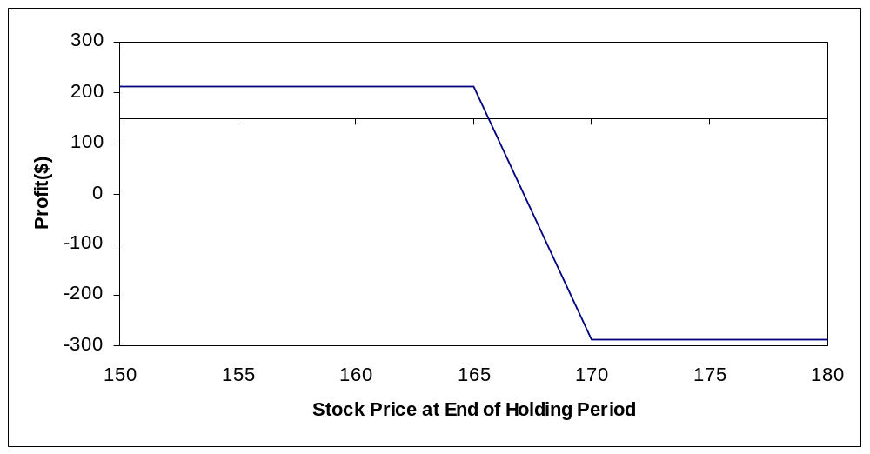

Breakeven stock price:

Maximum Profit : 212.50
Minimum Profit: -287.50
- Repeat problem 9, but close the position on September 20. Calculate the profit by hand when the stock price on September 20 is 155. Then use the spreadsheet or calculate by hand to find the profits for the possible stock prices on September 20. Generate a graph and use it to identify the approximate breakeven stock price
Time to expiration: 26/365 = 0.0712
(26 days between September 20 and October 16)
r_{c} = 0.0571

By hand with S_{T} = 155
165 Call

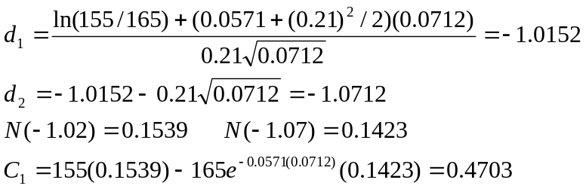 .
170 Call

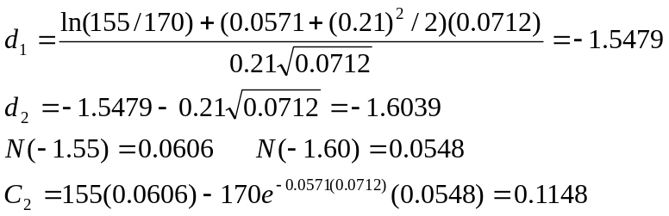 .

Spread Value = 0.1148 – 0.4703 =- 0.3555
Π = 100(-0.3555-6+8.125) = 176.95

The results are noticeably different from the values computed using a spreadsheet (see below), but the difference is due to the Black-Scholes model’s sensitivity to round-off errors.

S_{T} | Call Price at End of Holding Period |  | Profit
 | October 165 | October 170
150 | 0.1911 | 0.0487 | 198.26
155 | 0.6856 | 0.2232 | 166.26
160 | 1.8633 | 0.7546 | 101.63
165 | 4.0250 | 1.9698 | 6.98
170 | 7.2353 | 4.1469 | -96.34
175 | 11.2927 | 7.3433 | -182.44
180 | 15.8803 | 11.3707 | -238.46

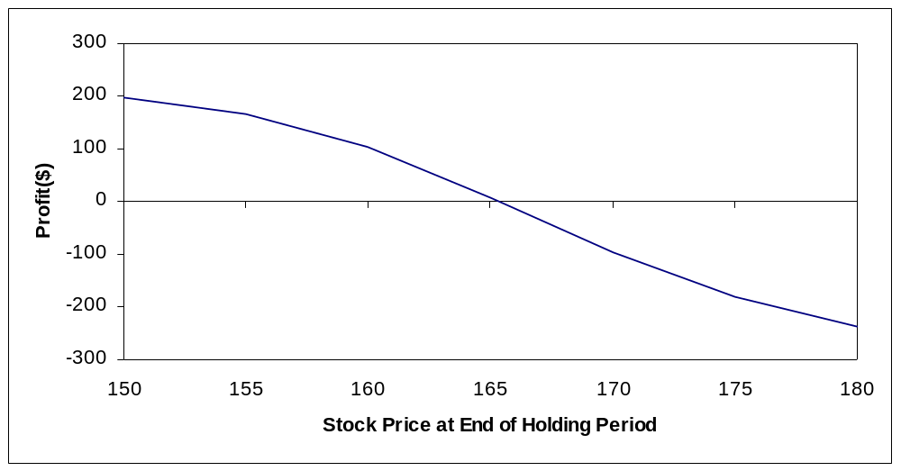

Approximate breakeven : 166

- Suppose you are expecting the stock price to move substantially over the next three months. You are considering a butterfuly spread. Construct an appropriate butterfuly spread using the October 160, 165, and 170 calls. Hold the position until expiration. Determine the profits and graph the results. Identify the two breakeven stock prices and the maximum and minimum profits.

Sell October 160 at 11.125
Buy two October 165’s at 8.125 each
Sell October 170 at 6

S_{T} | Call Price at End of Holding Period |  |  | Profit
 | October 160 | October 165 | October 170
150 | 0 | 0 | 0 | 87.50
155 | 0 | 0 | 0 | 87.50
160 | 0 | 0 | 0 | 87.50
165 | 5 | 0 | 0 | -412.50
170 | 10 | 5 | 0 | 87.50
175 | 15 | 10 | 5 | 87.50
180 | 20 | 15 | 10 | 87.50

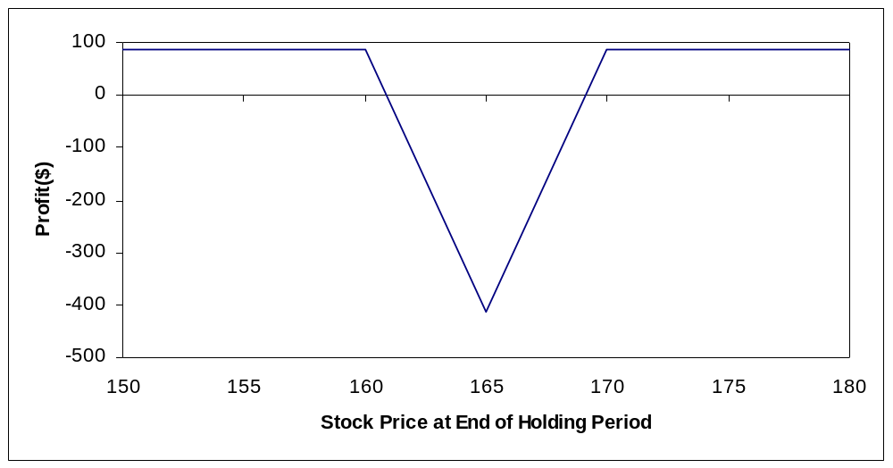

Breakevens:

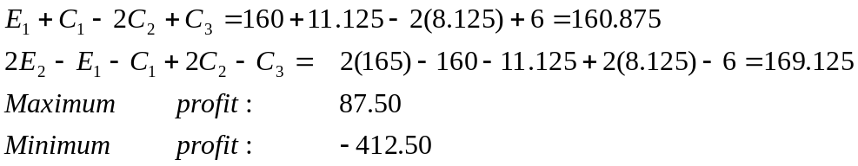
- Construct a calendar spread using the August and October 170 calls that will profit from high volatility. Close the position on August 1. Calculate the profit by hand when the stock price on August 1 is 155. Then use the spreadsheet or calculate by hand to find the profits for the possible stock prices on August 1. Generate a graph and use it to estimate the maximum and minimum profits and breakeven stock prices.

Buy August 170 at 3.25
Sell October 170 at 6

August 170: T=20/365=0.0548 r_{c} = 0.0535
October 170: T=76/365=0.2082 r_{c} = 0.0571

(Based on 20 days between August 1 and August 21, and 76 days between August 1 and October 16)

By hand with S_{T} = 155

August 170

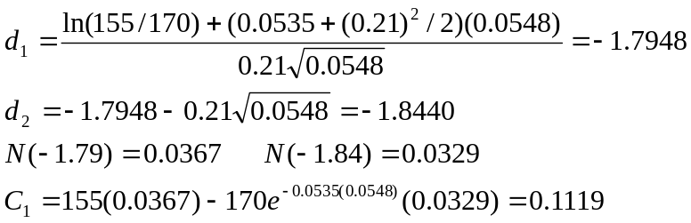 .
October 170

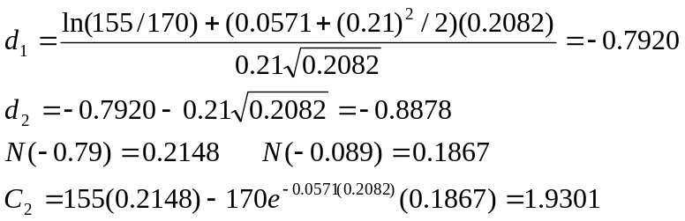 .

Spread Value = 0.1119-1.9301 = -1.8182
Π= 100(-1.8182-3.25+6)=93.18

These results are noticeably different from the values computed using a spread sheet (see below), but the difference is due to the Black-Scholes model’s sensitivity to the round-off errors.

S_{T} | Call Price at End of Holding Period |  | Profit
 | August 170 | October 170
150 | 0.0164 | 0.8844 | 188.2
155 | 0.1083 | 1.7301 | 112.82
160 | 0.4793 | 3.0639 | 16.53
165 | 1.5084 | 4.9781 | -71.97
170 | 3.5836 | 7.5118 | -117.83
175 | 6.8145 | 10.6446 | -108.01
180 | 10.9577 | 14.3064 | -59.87

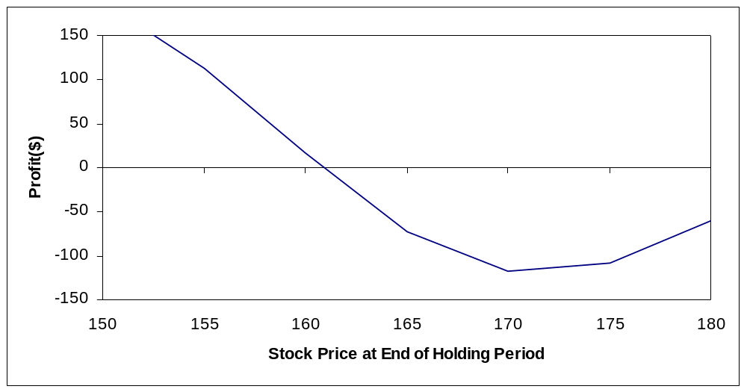
Maximum profit: 275 [if S_{T} = 0, profit = -100(3.25-6)=275]
Minimum profit: -117.53
Approximate breakevens : 161 and 181

- Using the Black-Scholes model, compute and graph the time value decay of the October 165 call on the following dates: July 15, July 31, August 15, August 31, September 15, September 30, and October 16. Assume the stock price remains constant. Calculate the time value on July 15 by hand and then use the spreadsheet or calculate by hand to find the time value in all of the cases.

Using the Black-Scholes models with r_{c} = 0.0571
On July 15, T=(16+31+30+16)/365 = 0.2548
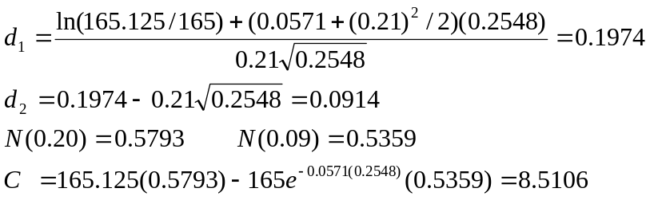

Intrinsic value = Max(0, 165.125-165)=0.125
Time Value = 8.5106-0.125 = 8.3856
This differs substantially from the value computed using a spreadsheet (see below) but the difference is due to the Black-Scholes model’s sensitivity to round-off errors.

Date | Time to Expiration | Time Value
7/15 | 0.25480 | 8.1278
7/31 | 0.21100 | 7.2918
8/15 | 0.16990 | 6.4452
8/31 | 0.12600 | 5.4473
9/15 | 0.08490 | 4.3732
9/30 | 0.04380 | 3.0431
10/16 | 0.00000 | 0.0000
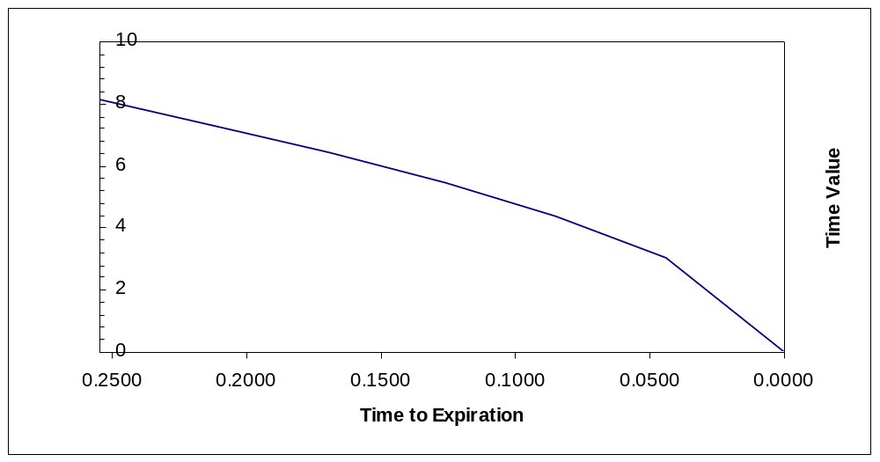

- Consider a riskless spread with a long position in the August 160 call and a short position in the October 160 call. Determine the appropriate hedge ratio. Then show how a $1 stock price increase would have a neutral effect on the spread value. Discuss any limitations of this procedure.

Using a spreadsheet for the Black-Scholes Model
August 160

The delta (N(d₁)) is found to be 0.7091
October 160
The delta (N(d₁)) is found to be 0.6855
If we buy the August 160 and write the October 160, the hedge ratio is the delta of the August call divided by the delta of the October call
0.7091/0.6855 = 1.0344
So sell 1.0344 October calls for each August call.
Suppose we buy 1000 August calls and sell 1034 October call. If the stock price increases by $1, the August calls increase by 0.7091 each for a total gain of $709. The October calls increase by 0.6855 each for a total loss (since we are short) of 1034 (0.6855) = $709
The procedure is valid only for very small changes in the stock price. Otherwise the hedge could have significant gamma risk.

- Construct a long straddle using the October 165 options. Hold until the options expire. Determine the profits and graph the results. Identify the breakeven stock prices at expiration and the minimum profit.

Buy the October 165 call at 8.125
Buy the October 165 put at 6.75

S_{T} | Option Price at End of Holding Period |  | Profit
 | October 165 Call | October 165 Put
150 | 0 | 15 | 12.50
155 | 0 | 10 | -487.50
160 | 0 | 5 | -987.50
165 | 0 | 0 | -1487.50
170 | 5 | 0 | -987.50
175 | 10 | 0 | -487.50
180 | 15 | 0 | 12.50

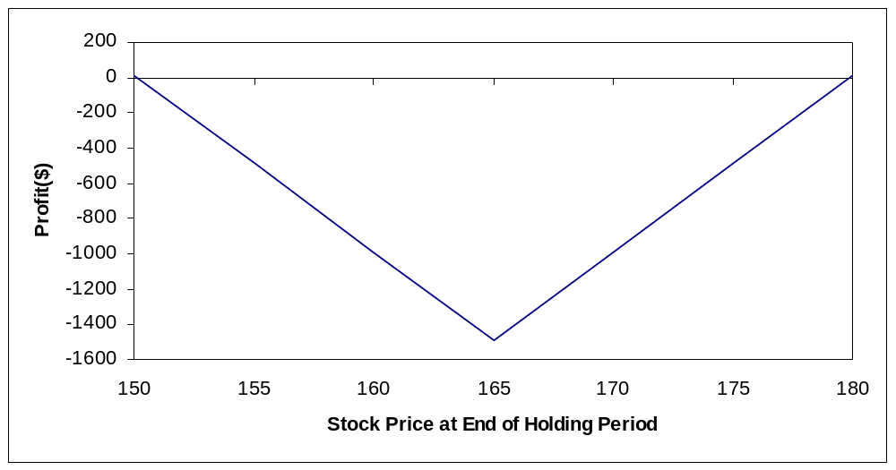

Breakevens:
E + C + P = 165 + 8.125 + 6.75 = 179.875
E – C – P = 165 – 8.125 – 6.75 = 150.125
Minimum profit: -1,487.50

- Repeat problem 15, but close the positions on September 20. Calculate the profit by hand when the stock price on September 20 is 155. Then use the spreadsheet or calculate by hand to find the profits for the possible stock prices on September 20. Generate a graph and use it to identify the approximate breakeven stock prices.

r_{c} = 0.0571 T = 26/365 = 0.0712
By hand with S_{T} = 155:

This value is calculated by hand in problem 6-10. C = 0.4703. with N(d₁) = 0.1539 and N(d₂) = 0.1423, the value of the put is

P =
Straddle Value = 0.4703 + 9.8008 = 10.2711
Π = 100(10.2711-8.125-6.75)= -460.39

These results are noticeably different from the values computed using a spreadsheet (see below), but the difference is due to the Black-Scholes model’s sensitivity to round-off errors.

S_{T} | Option Price at End of Holding Period |  | Profit
 | October 165 Call | October 165 Put
150 | 0.1911 | 14.5217 | -16.22
155 | 0.6856 | 10.0162 | -417.32
160 | 1.8633 | 6.1939 | -681.78
165 | 4.0250 | 3.3555 | -749.45
170 | 7.2353 | 1.5658 | -607.39
175 | 11.2927 | 0.6233 | -295.90
180 | 15.8803 | 0.2109 | 121.62

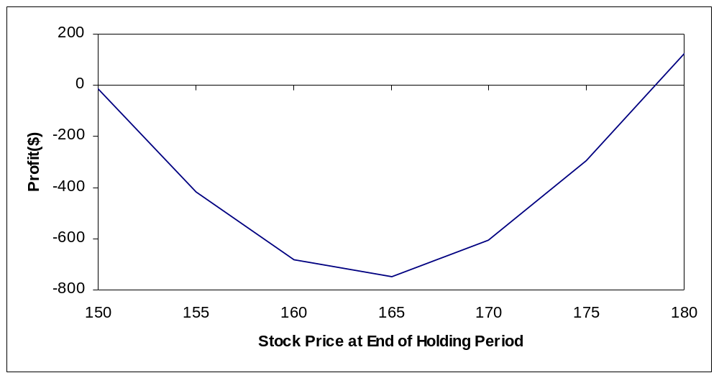
Approximate breakevens : 178 and 150

- Construct a long strap using the October 165 options. Hold the position until expiration. Determine the profits and graph the results. Identify the breakeven stock prices at expiration and the minimum profit. Compare the results with the October 165 straddle.

Buy two October 165 calls at 8.125 each
Buy one October 165 put at 6.75

S_{T} | Option Price at End of Holding Period |  | Profit
 | October 165 Call | October 165 Put
150 | 0 | 15 | -800.00
155 | 0 | 10 | -1,300.00
160 | 0 | 5 | -1,800.00
165 | 0 | 0 | -2,300.00
170 | 5 | 0 | -1,300.00
175 | 10 | 0 | -300.00
180 | 15 | 0 | 700.00

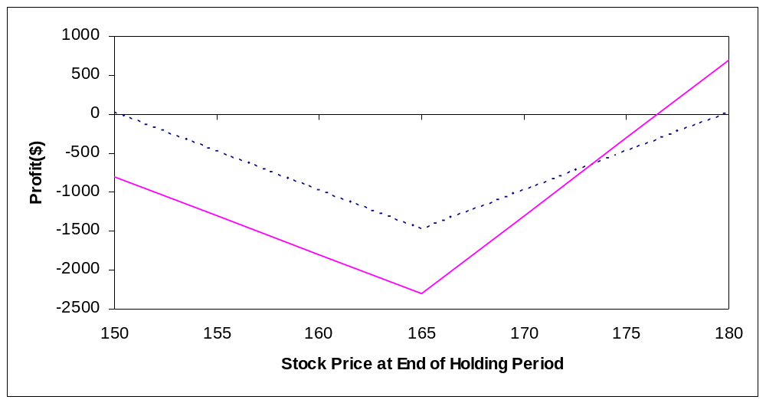

The graph shows the straddle (the dashed line) overlayed with the strap. The strap provides a higher profit on the upside and a larger loss on the downside.

Breakevens:

E+C+P/2 = 165+8.125+6.75/2 = 176.50
E-P-2C= 165-6.75-2(8.125) = 142
Minimum profit: -100(2(8.125)+6.75) = -2,300

- Construct a short strip using the August 170 options. Hold the position until the options expire. Determine the profits and graph the results. Identify the breakeven stock prices at expiration and the minimum profit.

Sell two August 170 puts at 7.5
Sell one August 170 call at 3.25

S_{T} | Option Price at End of Holding Period |  | Profit
 | August 170 Call | August 170 Put
150 | 0 | 20 | -2,175.00
155 | 0 | 15 | -1,175.00
160 | 0 | 10 | -175.00
165 | 0 | 5 | 825.00
170 | 0 | 0 | 1,825.00
175 | 5 | 0 | 1,325.00
180 | 10 | 0 | 825.00

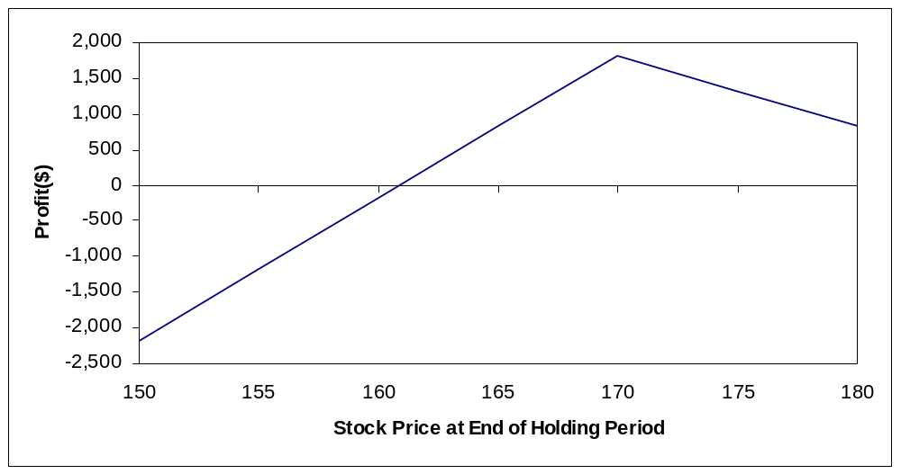
Note that only one breakeven point appears in the graph because of the range of the stock prices chosen.
Breakevens:

E+C+2P = 170+3.25+2(7.5) = 188.25
E-P-C/2 = 170-7.5-3.25/2 = 160.875

Minimum profit:
When S_{T} = 0, π= C+2P-2E = 100[3.25+2(7.5)-2(170)] = -32,175

- Analyze the August 160/170 box spread. Determine whether a profit opportunity exists and, if so, how one should exploit it.

Note : If the continuously compounded rate is 0.0535 then the discrete rate is
^{e0.0535} -1 = 0.055
buy August 160 call at 8.125.
Sell August 170 call at 3.25.
Buy August 170 put at 7.5.
Sell August 160 put at 2.75
The net premium is
8.125-3.25+7.5-2.75 = 9.625
The present value of the future payoff is
(170-160)(1.055)^{-0.1260} = 9.933
Where 0.1260 is the time to expiration from July 6 to Aug 21. Thus the net present value is
9.933 – 9.625 = 0.308
This spread is under priced so buy it. That is, buy the August 160 call and 170 put and sell the August 170 call and 160 put. This will generate a negative cashflow upfront of 9.625. At expiration you will receive 10, but the present value of 10 is more than the initial cashflow.
- (Concept Problem) The chapter presented two variations of the straddle: straps and strips. Another variation of the straddle is called a strangle. A strangle is the purchase of a call with a higher exercise and a put with a lower exercise price. Evaluate the strangle strategy by examining the purchase of the August 165 put and 170 call. As in the problems above, determine the profits for stock prices of 150, 155, 160, 165, 170, 175, and 180. Hold the position until expiration and graph the results. Find the breakeven stock prices at expiration. Explain why one would want to use a strangle.

Buy August 165 put at 4.75.
Buy August 170 call at 3.25.

S_{T} | Option Price at End of Holding Period |  | Profit
 | August 165 Put | August 170 Call
150 | 15 | 0 | 700.00
155 | 10 | 0 | 200.00
160 | 5 | 0 | -300.00
165 | 0 | 0 | -800.00
170 | 0 | 0 | -800.00
175 | 0 | 5 | -300.00
180 | 0 | 10 | 200.00

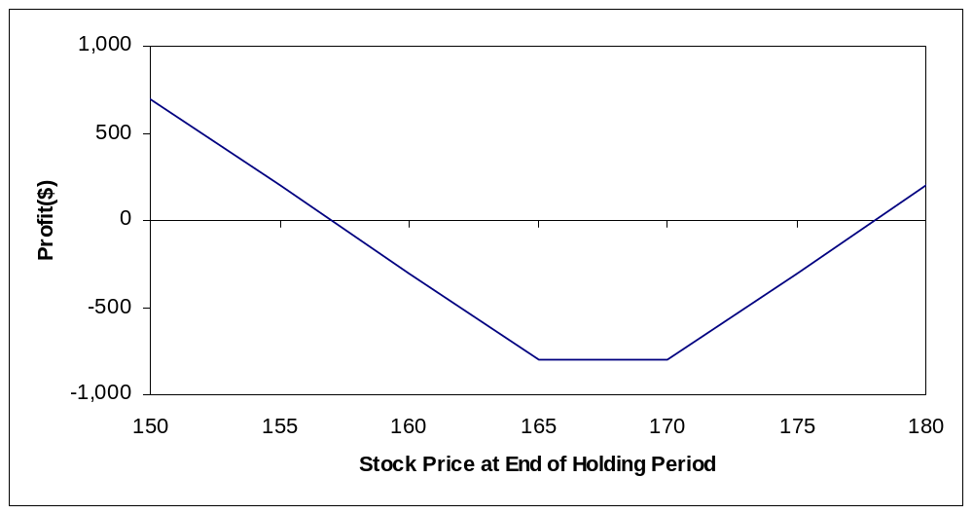

Breakevens:

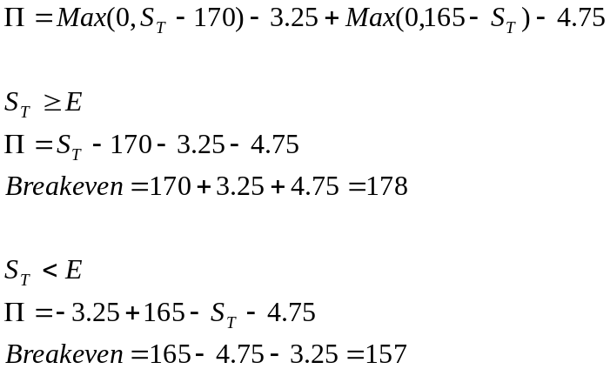

The strangle is similar to a straddle. However, by using a lower exercise price put or higher exercise price call the cost is lower, though the profit is also lower.

- (Concept Problem) Many option traders use a combination of a money spread and a calendar spread called a diagonal spread. This transaction involves the purchase of a call with a lower exercise price and a longer time to expiration and the sale of a call with a higher exercise price and shorter time to expiration. Evaluate the diagonal spread that involves the purchase of the October 165 call and the sale of the August 170 call. Determine the profits for the same stock prices you previously examined under the assumption that the position is closed on August 1. Calculate the profit by hand when the stock price on August 1 is 155. Then use the spreadsheet or calculate by hand to find the profits for the possible stock prices on August 1. Generate a graph and use it to estimate the breakeven stock price at the end of the holding period.

Buy October 165 call at 8.125
Sell August 170 call at 3.25

r_{c} = 0.0571

On August 1, the October 165 call has T=76/365 = 0.2082 and r_{c} = 0.0571
On August 1, the August 170 call has T=20/365=0.0548 and r_{c} = 0.0535
By hand with S_{T} = 155:

October 165 call

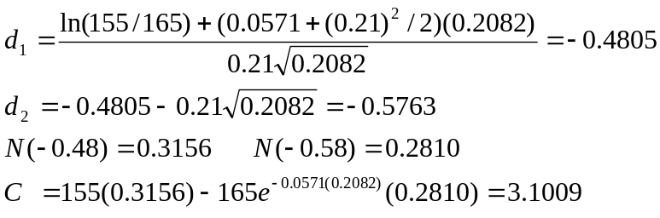

August 170 call

This result is calculated by hand in problem 6-12.

C=0.1119.
Value of Diagonal spread = 3.1009-0.1119 = 2.9890

Π= 100(2.9890-8.125+3.25) = -188.60

These results are noticeably different from the values computed using a spreadsheet (see below) but the difference is due to the black-scholes model’s sensitivity to round off errors

S_{T} | Option Price at End of Holding Period |  | Profit
 | October 165 Call | August 170 Call
150 | 1.5867 | 0.0164 | -330.4700
155 | 2.8800 | 0.1083 | -210.3300
160 | 4.7666 | 0.4793 | -58.7700
165 | 7.2909 | 1.5084 | 90.7500
170 | 10.4321 | 3.5836 | 197.3500
175 | 14.1154 | 6.8145 | 242.5900
180 | 18.2350 | 10.9577 | 240.2300

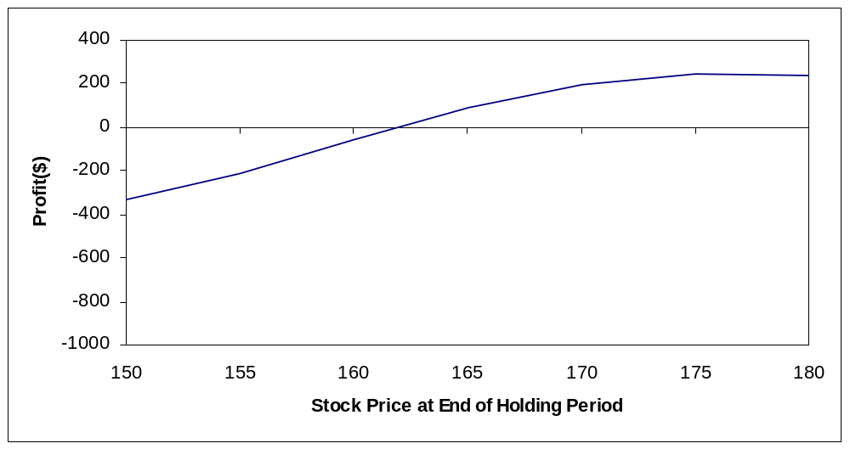

The breakeven is approximately 161.9

